Pre-Qualification Questionnaire (PQQ) for LNG ISO Tanks
Deadline: 9 October 2019
Dated: 6 September 2019
Document Produced by: Cameron Kerr, Mathew Starley

Contents
1 Introduction 3
1.1 SGN Overview 3
1.2 Our Values 4
2 Project Overview / Instructions 5
2.1 Scope 5
2.2 EU Procurement Directives 5
2.3 Timetable 5
2.4 Invitation to Tender 6
2.5 Queries 6
2.6 How to Complete and Respond to this PQQ 6
2.7 Definitions 6
2.8 Confidentiality and Intellectual Property Rights 6
2.9 Other Information 7
3 Selection Criteria 8
Appendix A - Prequalification Questionnaire 9

Introduction

SGN Overview
SGN is one of the UK’s largest and most innovative gas distribution network companies, operating across Scotland, southern England and in Northern Ireland.

Our Scotland network distributes gas across all of Scotland to 75% of households, including remote areas through the Scottish Independent Undertakings (SIUs) at Stornoway, Wick, Thurso, Oban and Campbeltown.

In Northern Ireland we have been granted the licence to bring natural gas to eight towns in the west, constructing high, intermediate and low pressure pipelines and mains. We are also contracted to maintain the gas transmission system and maintain the assets for the gas pipeline connection between Northern Ireland and Scotland.

Our Southern network stretches from Milton Keynes in the north, to Dover in the east and Lyme Regis in the west, including London boroughs to the south of the River Thames, distributing gas to around 90% of households.

SGN Network Coverage:

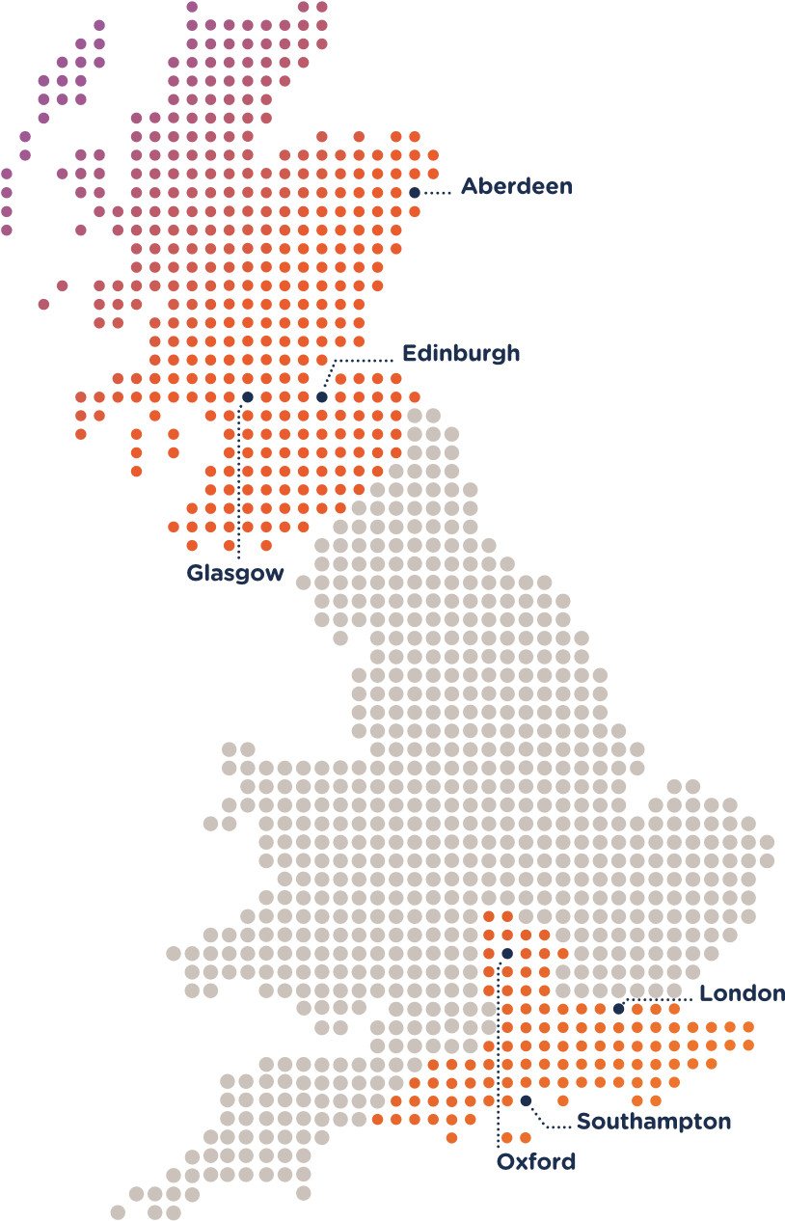

Our Values
Safety first
We take responsibility for our own safety and the safety of those around us

Driving performance
Efficiency, innovation and continuous improvement will help us deliver excellence and achieve commercial success

Putting people at the heart
We always work together, talk honestly and treat people with respect

Looking after customers
By listening to our customers, understanding their needs and keeping our promises we can deliver an excellent service that people trust

Sustaining our world
We maximise our effect on local communities and minimise our impact on the world

Project Overview / Instructions

Scope
SGN intends to appoint a Supplier to provide the design, manufacture, testing, inspection and delivery of up to 5 (five) 45ft transportable liquefied natural gas (LNG) ISO tanks. It is our current intention to procure 4 tanks, however provision will be included for an addition tank. The transportable LNG ISO tanks will be used to collect LNG from terminals, in both the United Kingdom and mainland Europe, for onward transportation and delivery to SGN’s LNG regasification plants in Scotland. Our target date for commissioning of the LNG ISO tanks is Summer/Autumn 2020.

The transportable LNG ISO tanks should be designed, manufactured, tested, inspected and certified to current UK and EU directives and legislation, and appropriate British, European, American and International technical codes and standards as appropriate. The units must comply with The Carriage of Dangerous Goods and Use of Transportable Pressure Equipment Regulations (CDG 2009) SI 2009, No 1348, and the provisions of: European Agreement Concerning the International Carriage of Dangerous Goods by Road (ADR); Regulations Concerning the International Carriage of Dangerous Goods by Rail (RID) for units which can be transported by rail; and The International Maritime Dangerous Goods Code (IMDG).

- LNG vessel is to be a cryogenic, vacuum insulated, ISO tank suitable for both LNG and liquid nitrogen (liquid nitrogen used for commissioning and maintenance purposes).
- Vessels to be designed for maximum LNG payloads within legislative and code constraints, target payload above 19 tonnes of LNG, based on an LNG density of 435kg/m3 and relief valve set point of 8.62 barg.
- Flow diagram with standard piping, valve and gauge layout to be provided by vendor and adhered to by the supplier. Note - there is no requirement for the vessels to be fitted with a discharge pump.
- Commercial proposal to consider and include design, manufacture, testing, inspection and certification of the vessel, as well as delivery of units to a specified location in Scotland, with complete engineering and construction records plus operations manual required prior to receipt of each unit.
- ISO Tanks dimension constraints set to 13,716mm x 2,438mm x 2,591mm (LxBxH)

A full technical specification will be contained within the Invitation to Tender pack.

EU Procurement Directives
This procurement is being carried out under the Negotiated Procedure in terms of the Utilities Contracts (Scotland) Regulations 2016.

Timetable
The provisional procurement timetable is set out below.

Event | Estimated Date or Date Range
PQQ Issued | 9 September 2019
Deadline for PQQ submission | 12 noon 9 October 2019
Invitation to Tender (ITT) Issued | 11 October 2019
Deadline for ITT | 23 October 2019
Tender Evaluation | 23 October – 20 November 2019
Standstill Period | 29 November – 9 December 2019
Contract award | 10 December 2019

Invitation to Tender
Suppliers who pass the minimum criteria detailed within Section 3 – Selection Criteria, will be invited to tender for the requirements.

Please Note: The draft ITT Documents (including specification) are available, and Suppliers should contact Cameron.kerr@sse.com for copies. Suppliers should take consideration of the above timeframe and are encouraged to review the ITT documents in advance and prepare their response as the ITT deadline will be 23 October 2019. Suppliers must however pass this PQQ to be invited to submit an ITT.

Queries
Any queries and/or requests for clarification in respect of this PQQ should be sent to cameron.kerr@sse.com.

How to Complete and Respond to this PQQ
The PQQ response sheet is contained in an excel spreadsheet within Appendix A of this document. Suppliers are invited to complete the Questionnaire sheet and submit it to the Authority at cameron.kerr@sse.com by the Deadline for PQQ Submission as specified in the Timetable. Please also ensure that the Declaration sheet contained within the attachment is correctly completed.

Definitions
In this PQQ, ‘Authority’ or 'we' means Scotland Gas Networks Plc, or anyone acting on its behalf, that is seeking to invite suitable Suppliers to participate in this procurement process. ‘Supplier’ or 'you' means the organisation that is completing this PQQ.

Confidentiality and Intellectual Property Rights
Suppliers shall not disclose any information in relation to either this PQQ, their PQQ response or subsequent queries and correspondence in whole or in part to any third party prior to either the award of a resultant Contract by the Authority or if permission is received in writing from a duly authorised representative. Suppliers are responsible for identifying any information of a proprietary or confidential nature within their response in order that it may be handled properly.

Suppliers are to restrict circulation and distribution of this PQQ to their suppliers and subcontractors on a "need to know" basis and then only for the purposes for which it has been supplied and when the supplier and/or subcontractor are bound by the same terms of confidentiality stated herein.

If you, as representative of your company, are not in agreement with this 'Confidentiality Notice' or you elect not to respond to this PQQ, please inform the Authority and delete all associated documents and correspondence, at all times treating the information contained herein as confidential. Otherwise, these confidentiality provisions are deemed accepted.

This PQQ and all associated documentation remain the property of the Authority. The Authority provides a license to the Supplier to use the information for the sole purpose of responding to this PQQ.

The Supplier grants the Authority a non exclusive, irrevocable and perpetual licence to copy, reproduce and use any intellectual property contained within its PQQ response for the purposes of carrying out the evaluation of the PQQ response and for entering into any resultant Contract (where applicable).

Other Information
Unless specifically requested by the Authority, you should not submit any additional documents with your PQQ response. No information contained in this PQQ, or in any communication made between the Authority and any Supplier in connection with this PQQ shall be relied upon as constituting a contract, agreement or representation that any contract shall be offered in accordance with this PQQ. Under no circumstances shall the Authority incur any liability in respect of this PQQ or any supporting documentation. In the event that none of the PQQ responses are deemed satisfactory, the Authority reserves the right to discontinue the process. Suppliers shall bear all costs and expenses incurred by them in the preparation and submission of their PQQ response. You must complete the PQQ response in the English language. Suppliers must complete all parts of the questionnaire fully - if you fail to do so your application may be disqualified.

Selection Criteria
The PQQ assesses the Suppliers suitability to carry out services under the contract, in terms of the responses provided in the PQQ Submission.

This section will be evaluated on a pass/fail basis according to the stated criteria.

Any Suppliers who do not pass all elements of the qualification stage may not be considered further.

Selection Criteria | Minimum Standards / Criteria to be Evidenced
Grounds for Mandatory Exclusions | This section is composed of mandatory exclusion questions. If ANY of the mandatory grounds for exclusion apply, a Supplier will fail the Selection Criteria and its offer will not be considered further.
Discretionary Exclusions | This section is composed of discretionary exclusion questions. If any of the discretionary grounds for exclusion apply, Supplier’s must provide evidence that remedial action has been undertaken. If, in the professional judgement of the Authority, the evidence (or proof) supplied is not sufficient in remedying the discretionary exclusion then the Supplier will fail, and the offer will not be considered.
Economic and Financial Standing | SGN will use a financial score from AMEE (financial review platform) which should show the Supplier to be above a 2 rating. If Suppliers score a 2 or below, SGN may request evidence to confirm that the Supplier has sufficient financial standing to not present an unmanageable risk.
Insurance | Suppliers must provide copies of their current insurance certificates as part of their tender submission. We will review these polices and further correspondence may be required between the Parties to reach agreement on the suitable insurance policy coverage.
Safety, Health and Environmental (SHE) | Suppliers must evidence robust health and safety policies and processes in operation. Suppliers will also be required to provide their up to date Health & Safety Policy and provide evidence of competency to carry out the works in accordance with, but not limited to, the Health & Safety at Work Act 1974.
Conflict of Interest | In this section, failure to disclose information relevant to this question or serious misrepresentation in relation to the information disclosed may result in your exclusion from this tender or the termination of any subsequent contract that may be awarded.
Technical and Professional Ability | Suppliers should evidence up to 3 previous examples of supplies or services carried out in the past five years to demonstrate that they have the relevant experience to deliver the scope of this contract. Suppliers who fail to evidence past experience in the view of SGN may result in failing this PQQ.
Quality Policies, Systems & Practices | Suppliers must provide evidence of robust quality policies and systems / practices in operation. Suppliers will also be required to provide details of their Quality Assurance accreditation or their up to date Quality Policy.

It is at the Authorities sole discretion whether these minimum standards have been met and whether your tender submission will proceed to award criteria.
- Prequalification Questionnaire

