Southern Gas Networks PLC (Kingsferry Gas Pipeline Replacement Project) Compulsory Purchase Order 2023

_____________________________________________

STATEMENT OF CASE
_____________________________________________

The Gas Act 1986
and
The Acquisition of Land Act 1981

The Southern Gas Networks PLC (Kingsferry Gas Pipeline Replacement Project) Compulsory Purchase Order 2023
Statement of Case
- Introduction
  - This document is the Statement of Case of Southern Gas Networks PLC (SGN) prepared in connection with the Southern Gas Networks PLC (Kingsferry Gas Pipeline Replacement Project) Compulsory Purchase Order 2023 (Order) pursuant to Rule 7(1)(b) of The Compulsory Purchase (Inquiries Procedure) Rules 2007 (the Inquiries Rules).
  - The Order was made by SGN on 12 October 2023 and was subsequently submitted to the Secretary of State for Energy Security and Net Zero (the Secretary of State) for confirmation.
  - If confirmed by the Secretary of State, the Order will authorise SGN to compulsorily acquire new rights in land required for (1) the construction and operation of a new gas pipeline under the river Swale between mainland Kent and the Isle of Sheppey and (2) the decommissioning of the existing intermediate gas pipeline suspended beneath the superstructure of the Kingsferry Bridge over the river Swale, and associated works (the Project).
  - The Order was made pursuant to section 9 and schedule 3 of the Gas Act 1986 (1986 Act) and having regard to the Department for Levelling Up, Housing and Communities’ Guidance on Compulsory Purchase Process and The Crichel Down Rules (July 2019) (the CPO Guidance).
  - As set out in paragraph 16.2, and following a 28-day objection period, a total of eight objections were made to the Order. The Secretary of State has therefore directed that a public inquiry should be held to determine whether the Order should be confirmed.
  - In accordance with the Inquiries Rules and CPO Guidance, this Statement sets out the full particulars of the case that SGN will put forward at the inquiry, including a detailed response to the objections made to the CPO, and provides a list of documents that SGN intends to refer to at the inquiry. It sets out SGN's justification for promoting the Order and explains why there is a compelling case in the public interest for the confirmation of the Order.
  - In this Statement the land which is the subject of the compulsory purchase order is referenced as the Order Land. The Order Land is described in this Statement and is shown coloured blue (acquisition of 'packages' of rights) on a map which forms part of the Order (Order Map).
  - The Order also contains a Schedule of Interests which identifies those persons with an interest in land affected by the Order.
  - SGN reserves the right to amend or expand this Statement as necessary.

Powers under which the Order was made
  - The Order was made under section 9 and schedule 3 to the 1986 Act and having regard to the CPO Guidance.
  - Section 9 of the 1986 Act states that the powers in schedule 3 (which provides for the compulsory purchase of land) have effect in relation to the holder of a gas transporter licence. Paragraph 1(1) of Schedule 3 of the 1986 Act provides that, “The Secretary of State, after consultation with the [Authority], may authorise a gas transporter to purchase compulsorily any land.”
  - In order that the Secretary of State can comply with their obligations in the 1986 Act, they must consult with Ofgem, though there is no need for the Secretary of State to obtain the consent or approval of Ofgem before making their decision. SGN requests the Secretary of State, in advance of any public inquiry and prior to making their decision, undertake consultation with Ofgem and provides Ofgem with a suitable period to comment on the making of the Order so that an appropriate amount of time is provided for Ofgem to provide comments (if any), and for those to be responded to by SGN (if required).
  - Paragraph 1(2) of schedule 3 to the 1986 Act confirms that “Land” includes any right over land, and that the Secretary of State’s power includes power to authorise the acquisition of rights over land by creating new rights, as well as acquiring existing ones. This includes the creation of rights equivalent to an easement and “restrictive rights”, akin to a restrictive covenant.
  - SGN holds a Gas Transporter Licence (Licence) under section 7 of the 1986 Act and is the licenced gas transporter for the south and south-east of England.
  - SGN may therefore be authorised to purchase compulsorily land and/or rights required to enable SGN to carry on the activities authorised by its Licence, and of the rights in land proposed to be acquired under the Order are needed for those purposes.
  - SGN is taking a proportionate approach to compulsory acquisition, and is only seeking to acquire rights over the Order Land as described in more detail later in this Statement.

- Description of the Order Land and the Project

Order Land
  - The Order Land comprises three main parts.
  - The first part is on the Isle of Sheppey side, where the land is a mixture of scrub, grass and marsh land reaching down to the shoreline of the river Swale.
  - The second part is the Kingsferry Bridge within which the existing Intermediate Pressure (IP) gas pipeline (Existing Pipeline) serving the Isle of Sheppey runs.
  - The third part is on the mainland side, where the land is a mixture of scrub, grass land, marsh land and farm land. Through this part of the Order Land runs part of the highway known as Ridham Dock Road which extends off Old Ferry Road to the west of the A249/Sheppey Way, under the Kingsferry Bridge and along the route of the foreshore to various industrial and commercial premises.
  - In addition, there are also several plots of land through which new pipeline apparatus will be drilled under the river Swale.
  - The land is shown on the Order Map and together comprises the Order Land.
  - Works have been undertaken on parts of the Order Land (both on the Isle of Sheppey and the mainland) by Southern Water Services Limited (Southern Water) to construct its Sheppey Pipeline Project between November 2022 and August 2023. The Southern Water works comprised HDD works with compounds on both the island and mainland sides. The works have now been completed, albeit there are still several compounds in situ that require remediation by Southern Water.
The Project
  - The Existing Pipeline crosses the river Swale via a service tunnel within the Kingsferry Bridge and is reaching the end of its asset life and requires replacement.
  - It is proposed to replace an approximately 518m long (plus vertical sections), 300mm diameter section of the Existing Pipeline with a new pipeline under the river Swale (New Pipeline) which will be installed by Horizontal Directional Drilling (HDD). The New Pipeline would connect back into the Existing Pipeline either side of the Kingsferry Bridge. The New Pipeline section will be 1.10km long and have a 400mm diameter. Once the New Pipeline is installed, the Existing Pipeline will then be fully decommissioned and removed from the Kingsferry Bridge. Together these are the Works which comprise the Project.
  - Following decommissioning SGN is removing the Existing Pipeline rather than leaving it in situ for two reasons. First, section 6.8 of the overarching Licence for Gas Pipelines and Agreement for Standard Conditions dated 7 March 2024 (NR Licence) between Network Rail Infrastructure Limited (Network Rail) and SGN obligates SGN to remove the above ground pipeline within 12 months of cessation of its use. Second, it would be SGN's preference in any event to remove the decommissioned pipeline which would otherwise need to be maintained in situ in perpetuity (as a consequence of the continuing corrosion of the Existing Pipeline material and support), thereby creating a burdensome ongoing requirement for regular asset surveys and (as required) remedial works to ensure the safety of the bridge structure.
  - SGN has undertaken engagement on the preferred strategic proposal with a wide variety of stakeholders including relevant statutory bodies, political representatives, potentially affected landowners and the general public through a variety of approaches. Feedback from engagement will continue as detailed design work matures. This supports the acquisition of necessary rights for the construction and operation of the infrastructure through voluntary agreements or compulsory purchase where necessary.
  - The component parts of the Project are described below:
Construction of New Pipeline
  - Construction of the New Pipeline will be undertaken using a combination of trenched installation techniques across open land, and trenchless methods, such as HDD, to cross obstacles where appropriate, including (but not limited to) roads, buried utilities and watercourses.
  - The component parts are described in more detail below:
    - Working corridor comprising:
      - Pipe trench: this is the excavation within which the 400mm pipe will be installed.
      - Working areas: these are areas on either side of the pipe trench which are needed to allow the safe and efficient movement of personnel, plant and machinery used to perform the construction activities required. These areas will include space to weld, inspect and coat the pipeline before it is lowered into the trench.
      - Topsoil bund: these areas will be used for the storage of the topsoil.
      - Subsoil bunds: these areas will be used to store the soil that has been excavated to create the trench. The subsoil removed from the trench will be stockpiled adjacent to the area where it was removed from to ensure the soil is returned to the same areas during reinstatement. The subsoil will be stored as far as practicable away from the topsoil to prevent mixing of soil types.
      - Running track: the working corridor will include a running track for construction traffic along the pipeline route. The running track will be approximately 8m wide increasing up to 12m where there are passing places. This is particularly important to ensure access in the event of an emergency.
      - Fence: to ensure compliance with the CDM regulations the working area will be fenced off to define the area in which the construction activities will be undertaken. Fencing types will be selected based on the purpose required (e.g. to demarcate vehicle and pedestrian/working areas where required, to provide security in high-risk areas).
    - The construction works will be serviced from one construction compound on the mainland and one on the island side. The main compound is located on the south side of the river Swale adjacent to and accessed from Ferry Bridge Road. This compound will hold contractors' offices and welfare infrastructure, materials, plant and equipment stores. The compound will be secured by perimeter hoarding and full time out of hours security resources. During the decommissioning works, the compound to the south of the river Swale will move nearer to southern abutment of the Kingsferry Bridge.
    - The compound on the north side of the river Swale will be primarily for material storage and local contractor welfare facilities. This compound will service the laydown area for the HDD pipeline string activities prior to pulling the pipeline into the HDD.
    - In advance of main construction works and compound installation, various surveys, ecological and archaeological mitigation activities are to be undertaken. These activities will include contemporary habitat surveys and records, relocation of great crested newts and reptiles as necessary along with protection infrastructure for watercourses, ponds and any other ecological areas of interest.
    - The construction of compounds and main works will be overseen by ecological specialists and undertaken under controlled risk assessments and methods of working. Archaeological specialist input would be requested should any archaeological assets be found during the course of construction and/or the main works.
    - The compounds and working areas will be accessed from Ferry Bridge Road and Sheppey Way via temporary access roads within the site. The design and construction of temporary access roads and laydown areas will provide for protection to the existing landscape including temporary drainage controls via local pumping. Temporary drainage systems and controls will be detailed within the construction environmental management plan.
    - The section of the New Pipeline under the river Swale will be installed using HDD techniques with a reception pit installed on the north side of the river Swale and a launch pit on the south side. This section of pipeline will be prefabricated as a pipe string that will be pulled back by winch towards the southern pit.
    - The connecting pipelines on either side of the river Swale will be installed via standard pipelaying open cut trench techniques to the connection points on the Existing Pipeline. Sections of Existing Pipeline within the public highway will be undertaken with standard highways notices (NRSWA) to standard installation and reinstatement procedures and specifications.
    - The New Pipeline connections will be made using flanges at each connection point that are to be installed on the Existing Pipeline. The Existing Pipeline will be exposed within supported excavations, and the new pipe flanges installed under pressure by a specialist Contractor. These works will all be undertaken and controlled by SGN through its own internal permits to work and standard procedures.
Removal and decommissioning of the Existing Pipeline
  - The removal of the Existing Pipeline will be undertaken in discrete phases to allow for Network Rail interfaces, restricted access and methods of working:
- Phase 1 - Removal of the Existing Pipeline from within the existing Kingsferry Bridge south abutment;
- Phase 2 - Removal of the Existing Pipeline from under the existing Kingsferry Bridge superstructure on the river Swale south foreshore;
- Phase 3 - Removal of the Existing Pipeline from within the Kingsferry Bridge southern tower;
- Phase 4 - Removal of the Existing Pipeline from within the Kingsferry Bridge service tunnel section;
- Phase 5 - Removal of the Existing Pipeline from within the Kingsferry Bridge northern tower;
- Phase 6 - Removal of the Existing Pipeline from within the existing Kingsferry Bridge south abutment; and
- Phase 7 - Removal of the Existing Pipeline from under the existing Kingsferry Bridge superstructure on the river Swale south foreshore
    - The removal works’ final scope, methodology and interfaces will be subject to the Network Rail Asset Protection Team (ASPRO) process. The ASPRO process has a number of defined stages, but in overview provides that following the initial notification which has been made to Network Rail by SGN, early engagement discussions will lead to an agreed, detailed, cost estimate being provided to SGN by Network Rail to cover Network Rail's approval of the design and implementation of the Project works affecting Network Rail property. Further detailed discussions are then expected to lead to the ASPRO Team at Network Rail being able to agree with SGN an approved works package and a design and delivery programme to be secured in an asset protection agreement.
    - The removal works will be serviced from two secure contractor compounds either side of the river Swale adjacent to the Kingsferry Bridge north and south abutments. Access to the compounds will be via Ferry Bridge Road and Sheppey Way.
    - Access to the work areas will be via the slipways to the north and south foreshores and adjacent to the tower entrances on the Kingsferry Bridge. A temporary lane closure on the northern lane of the bridge section of Sheppey Way will be required when access or egress to the abutment towers is required.
    - Various proprietary access scaffold systems will be installed within the specific phases of pipeline removal to suit the decommissioning and redundant pipeline removal requirements of the Works.

- Need for and benefits of the Project
  - SGN operates and maintains the gas distribution network in south and south-east England and is required under section 9 of the 1986 Act to develop and maintain an efficient and economical pipe-line system for the conveyance of gas within its licenced area. Such a duty is also reflected in SGN's Licence and aligns with the Strategic Aim 6 of SGN's Gas Network Innovation Strategy 2018, which states:
"Use innovation to reduce the safety risks associated with essential activities now and in the future."
  - SGN has identified a need to replace the Existing Pipeline due to the cumulative effect of a number of project drivers, primarily safeguarding the continued and uninterrupted supply of gas to the Isle of Sheppey, and the asset health of the Existing Pipeline. The principal drivers are detailed below.
Energy Security and Reliability of supply of gas to the Isle of Sheppey
  - The Existing Pipeline is the only gas supply to the Isle of Sheppey supplying approximately 15,000 domestic and commercial customers, including Sheppey Community Hospital, 12 primary schools and two secondary schools, care homes, three prison facilities (two of which are maximum security), extensive port facilities and multiple industrial and commercial businesses. All of these customers are reliant on a continued supply of gas.
  - In addition, having assessed proposed plans for domestic and commercial expansion within the Swale Borough Local Plan (adopted July 2017) (Local Plan), SGN have predicted that between 2016 and 2026 the demand on gas supply will increase by 10%.
Asset Health of Existing Pipeline
  - The Existing Pipeline is at the end of its operational life having been installed in the late 1950s. The Existing Pipeline is in poor condition and has had 15 gas leaks over its length since 1992, including one in 2016 and three in 2017. More recently, in October 2019 and in October 2022 leak events shut Ridham Dock Road and the Kingsferry Bridge for a number of weeks. The Kingsferry Bridge is a combined road and railway vertical-lift bridge connecting the Isle of Sheppey to mainland Kent. The 2022 leak caused the suspension of local train services between Sittingbourne and Sheerness and inconvenience to local businesses and residents. The leaks have occurred despite the Existing Pipeline operating well below its maximum gas pressure of 7 bar. The Existing Pipeline and steel support gantry located within the service tunnel under Kingsferry Bridge is also corroding, caused in part due to harsh environmental conditions.
  - SGN are concerned that the condition of the Existing Pipeline could result in further gas leaks, therefore presenting health and safety risks to SGN operatives repairing faults, particularly within the confined space of the service tunnel beneath the Kingsferry Bridge, and, in extreme cases, risk the integrity of the structure of Kingsferry Bridge and its users.
  - It is now imperative that SGN replace the Existing Pipeline as soon as possible. Under the Special Conditions of SGN's Gas Transporter Licence (Special Conditions), OFGEM requires that SGN deliver the Project prior to the end of its current RIIO-GD2 price control period on 31st March 2026, and has provided funding to align with that period. If the Project is not delivered, is delayed or is only partially delivered, the Special Conditions provide that the funding may be reduced or adjusted accordingly.
Ofgem
  - Ofgem issued a RIIO-2 Final Determination in respect of the Project on 8 December 2020. This confirmed the Project as a PCD (price control deliverable) to be delivered by SGN within the RIIO-2 period.
Policy Support for reinforcement and development of gas infrastructure
  - The need for the Project is reflected in the strong policy support for the Project set out below:
National Energy Policy
  - 23 million users currently rely on Britain's energy network, with gas representing almost 30 per cent of final energy consumption and 40 per cent of electricity generation. The Energy White Paper published in December 2020 (the White Paper) sets out how the UK will reach net zero emissions by 2050. Although this transition will involve a move away from gas towards a low-carbon system at page 76, it is acknowledged that this transformation of Britain's energy system will rely in part on existing gas infrastructure to maintain supply.
  - At page 84, the White Paper acknowledges that the UK:
'will continue to rely on natural gas for some years, even as we work to largely eliminate carbon emissions from the entire energy system'
and therefore gas networks need to continue to evolve to ensure security of supply.
  - The UK Government’s British Energy Security Strategy (April 2022) (the BESS) sets out the Government’s aims to reduce reliance on coal and gas and to generate and store more renewable and nuclear energy. However, it acknowledges that
'Gas is currently the glue that holds our electricity system together and it will be an important transition fuel.'
  - Building on the BESS, the Government has recently published the following plans:
'Powering Up Britain' Energy Security Plan (March 2023) (the Energy Security Plan); and
'Powering Up Britain' The Net Zero Growth Plan (March 2023) (the Net Zero Growth Plan).
  - The Energy Security Plan sets out the Government's plans to enhance the UK's energy security through diversifying the range of energy sources. Energy security necessitates a smooth transition to low carbon energy, meaning that natural gas will play a vital role for many years to come.
  - The Net Zero Growth Plan confirms that, "As we transition to net zero, fossil fuels will retain a crucial role in the energy system, until there are credible clean energy alternatives that can replicate their role”.
Energy NPS
  - The UK Government recognises the importance of new energy developments and has published a series of National Policy Statements (NPS) which set out national policy for nationally significant energy infrastructure. Although applying strictly to those projects falling within the definition of Nationally Significant Infrastructure Projects (NSIPs) in the Planning Act 2008, the NPSs may also be a material consideration for projects progressed under the Town and Country Planning Act 1990 (as amended).
  - For the Project, the NPS for Energy (NPS EN-1), and the NPS for Gas Supply Infrastructure and Gas and Oil Pipelines (NPS EN-4), are material considerations and demonstrate national policy support for the Project.
  - Following consultations on draft replacement NPS in autumn 2021 and March 2023, the new suite of Energy NPS were published on 22 November 2023. These reflect the two core energy sector themes that have developed since the previous NPS (i.e. energy security and net zero) and overall, provide even stronger policy support for the Project than the revised draft Energy NPS detailed in the Statement of Reasons accompanying the Order.
NPS EN-1
  - The overarching NPS for Energy (NPS EN-1) sets out the Government's policy for delivery of major energy infrastructure.
  - EN-1 explicitly recognises that, "the use of unabated natural gas…for heating, cooking, electricity and transport, and the production of many everyday essentials like medicines, plastics, cosmetics and household appliances, will still be needed during the transition to a net zero economy."
  - Paragraph 3.4 recognises that "Gaseous fuels have a key role in the UK energy landscape, accounting for around 30 per cent of UK energy production in 2020, and 40 of demand". Gas is used "in the domestic sector for heating and cooking, in the industrial sector, as a source of energy and as a feedstock and, in the power generation sector, as a reliable source of flexible generating capacity". Para. 3.4.4 states that a diverse mix of gas supply infrastructure, including pipelines, is required to meet energy objectives. Gas infrastructure must be sufficient to:
    - meet 'peak' demand for gas;
    - allow for the "sustained delivery of large volumes of gas, for example, demand over a particularly cold winter"; and
    - "provide access to the most competitive gas supplies, because the price of gas sources will vary over time, this leads to some redundancy in gas supply infrastructure."
  - Part 3 of EN-1 explains why the government sees a need for significant amounts of new large-scale energy infrastructure to meet its energy objectives and why the government considers that the need for such infrastructure is urgent. Paragraphs 3.2.5 and 3.2.7 advise that the Secretary of State should assess applications covered by EN-1 on the basis that the government has demonstrated that there is an urgent need for those types of infrastructure and substantial weight should be given to this need.
  - EN-1 explicitly recognises that despite a transition to low carbon alternatives "…we will still need new gas infrastructure" and "we cannot be certain on the precise role of natural gas, or gas infrastructure, in the future." In addition, "Natural gas infrastructure might also be repurposed in the future for use by other gases required to deliver a net zero economy, such a slow carbon hydrogen or for the transportation of carbon dioxide to storage. Therefore, there is an ongoing need for retaining and developing the infrastructure for importing, storing and transporting gas".

NPS EN-4
  - The NPS for Natural Gas Supply Infrastructure and Gas and Oil Pipelines (EN-4) recognises at para. 1.1.1 that "The efficient import, storage and transmission of natural gas and oil products is crucial to meeting our energy needs during the transition to a low carbon economy." EN-4 goes further and states that "This reflects the ongoing need for oil and unabated gas during the transition to a net zero economy for heating, cooking, electricity and transport, and the production of many everyday essentials like medicines, plastics, cosmetics and household appliances. This will enable secure, reliable, and affordable supplies of energy as we develop the means to address the carbon dioxide and other greenhouse gases associated with their use, including the development of low carbon alternatives."
  - Development of the Project is therefore in line with the Government's current NPS EN-1 and EN-4.
NPPF
  - The National Planning Policy Framework (the NPPF) is also material to, and demonstrates national policy support for, the Project. In particular, the NPPF sets out a presumption in favour of sustainable development. In this context it emphasises three overarching objectives:
    - An economic objective - to help build a strong, responsive and competitive economy, including by identifying and coordinating the provision of infrastructure;
    - A social objective - to support strong, vibrant and healthy communities; and
    - An environmental objective - to protect and enhance our natural, built and historic environment, including making effective use of land, improving biodiversity, using natural resources prudently, minimising waste and pollution, and mitigating and adapting to climate change, including moving to a low carbon economy.
  - For the reasons set out above the Project is sustainable development that meets all of these objectives.
  - The NPPF requires the timely provision of all types of physical infrastructure, including energy. Local plans are also required to take account of the need for strategic infrastructure, including those of national significance. One of the core principles of the NPPF requires account to be taken of local strategies to improve health, social and cultural well-being and deliver sufficient community and cultural facilities and services to meet local needs.
  - The NPPF also requires local planning authorities to include policies to deliver the provision of infrastructure in their local plans. It also requires that they should work with other authorities and service providers to assess the quality and capacity of infrastructure to meet the forecast demands arising from the local plan and also the need for strategic infrastructure (including nationally significant infrastructure) within their areas.
Local policy
  - The Local Plan sets out the planning policies for the Swale Borough Council administrative area.
  - The Local Plan includes a series of core policies that take important issues for Swale and create the necessary linkages with the policy themes, set out in national planning policy and other local plan policies. One such core policy is the provision of community facilities and services to meet local needs.
  - Chapter 5 of the Local Plan acknowledges that to meet the growth requirements for Swale, development in the local area will need to ensure that sufficient infrastructure is provided.
  - Whilst Policy CP 6 (Community facilities and services to meet local needs) puts the onus on new development to ensure that there is sufficient infrastructure in place to support it, both this policy and its supporting text underline the importance of infrastructure delivery, with paragraph 5.5.9 stating. "The impacts of development on the built and natural environment, utilities and community services needs to be managed. This may involve protecting existing infrastructure, identifying where there is capacity and or securing the timely provision of new infrastructure, which in itself may require land allocations to be made to accommodate it." Statement 6 expands the list of infrastructure requirements included at paragraph 5.5.9 to include utilities services such as non-renewable energy infrastructure.
Summary of the benefits of the Project
  - The key benefits that will arise from the Project, which are in-line with the aforementioned duties, policies and guidance, are:
    - Energy security/reliability of supply of gas to the Isle of Sheppey; and
    - Avoidance of leakage risk as a consequence of the asset health of the Existing Pipeline.

- Alternatives
  - When considering options for interventions with the Existing Pipeline, SGN followed its '4R Intervention Strategy' (as shown in Figure 1 below). This strategy is designed to maximise the asset life and minimise the capital expenditure of any intervention and in doing so sets out an order when considering the intervention type. This consideration is key in delivering customer value and focuses on the lighter intervention options of repairing and refurbishing the asset before considering more severe interventions such as component replacement and full rebuild.

Figure 1 – 4R Intervention Strategy.
  - The following options, in line with the 4R strategy, were considered by SGN in the development of the Project.
The 'Do Nothing' Option
  - Not undertaking any works to secure the repair or replacement of the Existing Pipeline was not considered by SGN to constitute a feasible option. This was due to two factors:
    - recent gas leaks; and
    - the continuing corrosion of the Existing Pipeline material and supports.
  - A failure to proceed with appropriate works would risk further disruption to the transport network as well as a potential for a complete gas supply failure to customers on the Isle of Sheppey. This would also amount to non-compliance with SGN's statutory duties to operate, maintain and develop its gas distribution networks in an economic, efficient and coordinated way.
The 'Pre-emptively Repair' Option
  - Explorations of the Existing Pipeline by SGN determined that leaks would likely become a regular occurrence requiring greater resources to maintain a continued supply. The degrading structure of Kingsferry Bridge and the service tunnel could potentially further jeopardise the integrity of the Existing Pipeline, meaning that during the period of any repair the entire supply to the Isle of Sheppey would potentially be cut off. In addition, the potential health and safety risks to workers repairing gas leaks or the Existing Pipeline's support structures were considered by SGN to be too great for this option to be considered and it was hence discounted by SGN.
The 'Repair on Failure' Option
  - This option was discounted by SGN on the basis that it would result in the unplanned failure in gas supply to the Isle of Sheppey with a prolonged period of no supply during repairs, potentially at a time of year when customers need to heat their homes and businesses. This option would also lead to potentially hazardous working conditions, especially within the service tunnel, for workers trying to repair the Existing Pipeline in-situ. This approach would be contrary to two of SGN's core values of reliability and safety and would result in non-compliance with SGN's statutory undertaking which obliges the company to maintain an efficient and economic pipeline network for the conveyance of gas. The emergency actions required to undertake repairs could also have an adverse impact on the sensitive surrounding areas. Therefore, a reactive 'repair on failure' approach is deemed by SGN to be inappropriate as compared to a planned, proactive approach.
The 'Replace on Failure' Option
  - This option would involve the replacement of sections of the Existing Pipeline, or the whole pipeline, in the event of a failure. There were three reasons why SGN discounted this option. Firstly, SGN considered this option would likely result in an unacceptable partial or whole cessation of the gas supply to the Isle of Sheppey during the leak and for the duration of replacement, potentially at a time of year when customers need to heat their homes and businesses. Secondly, the option would require work to be undertaken within potentially confined, hazardous spaces during an uncontrolled release of gas. That would be an unacceptable risk for SGN personnel due to health and safety concerns. Thirdly, the limited space within the service tunnel (located within the superstructure of the Kingsferry Bridge) would require installation of a second pipeline directly adjacent to the Existing Pipeline, which would not be feasible. In addition, it was noted that a benefit of not installing the new pipeline within the structure of Kingsferry Bridge would be the removal of potential future disruption to rail and road services due to replacement or repair operations.
The 'Replacement' Options
  - Having discounted the options described above, SGN then considered options which would provide for a new pipeline outside of the structure of the Kingsferry Bridge. Any replacement pipeline would need to be pre-emptively delivered prior to the failure of the Existing Pipeline.
  - Taking into account constraints posed by the geography of the existing pipeline network, ecological designations and land take, four possible routes for a replacement pipeline were identified and taken forward for further study. The replacement options were reviewed in a series of route walk throughs undertaken by SGN asset managers and specialist advisors to identify the various matters and risks that would need to be potentially considered and addressed to progress each option to the detailed design and construction stage.
  - These route walkthroughs identified all enabling and engineering requirements to determine the relative complexity and difficulty of each replacement option (including environmental impacts, construction and access, third party interfaces, land requirements and consents etc.) and these were summarised within individual route option reports.
  - SGN considered the following options to pre-emptively replace the Existing Pipeline with a new gas pipeline:
    - Replacement Option 1: Crossing the river Medway from the Isle of Grain to Sheerness Docks;
    - Replacement Option 2: Via horizontal directional drill (HDD) between Sheppey Bridge and Kingsferry Bridge;
    - Replacement Option 3: Via HDD north of Sheppey Bridge;
    - Replacement Option 4: Crossing the river Swale from Kent to the Isle of Sheppey via HDD (this being the preferred option).
The relative location of the four replacement options are detailed in Figures 2 and 3
Figure 2 – Relative location and layout of the four replacement option routes

Figure 3 – Relative location and layout of replacement option routes 2,3 and 4
Replacement Option 1: Crossing the river Medway from the Isle of Grain to Sheerness Docks
  - The Existing Pipeline extends onto the Isle of Sheppey through the Kingsferry Bridge and then along Brielle Way to the north-west on to an existing gas distribution facility near to the Sheerness Docks. Consequently, Replacement Option 1 was considered, as it would have enabled Kingsferry Bridge to be bypassed completely by the construction of a new intermediate pressure gas pipeline beneath the Medway Estuary to the north of the Isle of Sheppey, to enter directly into the gas distribution facility (see Figure 4). Construction of this pipeline would require a trenchless method under the Medway Estuary, either tunnelling or HDD for over 2km. This would be a technical challenge, given that this distance is at the limits of HDD techniques (typically 1.5 km). If this replacement option was undertaken, the existing gas main from Kent within the Kingsferry Bridge and under the river Swale would still need to be either replaced or decommissioned. Furthermore, consultation would be necessary with the Environment Agency with respect to breaching the existing flood defences at the shoreline on the Isle of Grain.
Figure 4 – Discounted Option: Proposed route for the new pipeline (green line to be installed using traditional open-cut methods, and red line installed via directional drilling). The Isle of Grain is shown in the left of the image, Sheerness Docks are visible in the right of the image.
  - In addition to the outlined technical difficulties, the river Medway corridor is designated as a Ramsar, Special Protection Area (‘SPA’), a Marine Conservation Zone and a Site of Special Scientific Interest (‘SSSI’). Although, the proposed working areas would not necessarily have been located within these designations, it was recognised by SGN that this replacement option would likely have an impact upon each of these designated sites. Given the complexity of the engineering required, the risk of potential impacts to the channel bed, hydrogeology, geomorphology and ecology of the Medway Estuary the impacts of Option 1 were considered likely to be significant.
Replacement Option 2: Via horizontal directional drill between Sheppey Bridge and Kingsferry Bridge
  - Replacement Option 2 comprised a route to the north of Kingsferry Bridge and south of the Sheppey Crossing bridge. Replacement Option 2 provided for a new pipeline to be drilled beneath the Swale onto the Isle of Sheppey to the north of Sheppey Way. The pipeline would then cross beneath both the highway and railway to connect into the existing gas governor on the Isle of Sheppey. The proposed drill was anticipated to be approximately 415m in length across the Swale, with an additional approximately 100m drill to connect into the governor (see Figure 5). Notwithstanding its distance from the Option 1 routes, this route beneath the Swale would impact the same designated sites as Option 1.
Figure 5 - Discounted Option: Proposed route for the new pipeline (with red line installed via directional drilling). Mainland England is shown in the right of the image, and the Isle of Sheppey is shown in the right of the image, the Swale is in the centre.
  - Whilst the engineering complexities for Replacement Option 2 were not considered by SGN to be as great as the proposed crossing beneath the Medway Estuary provided for in Replacement Option 1, the required redirection of the gas pipeline to the south upon entry to the Isle of Sheppey would require drilling beneath both the highway and railway. This would remain technically very difficult and require significant work to ensure the safety of the operational pipeline and users of Kingsferry Bridge. The engineering complexities and risks identified with this option (not least for the operational railway), alongside its potential impacts on designated sites, were deemed to be significant by SGN. This replacement option encountered very similar environmental conditions to Replacement Options 3 and 4.
Replacement Option 3: Via horizontal directional drill north of Sheppey Bridge
  - Replacement Option 3 required the new pipeline to be drilled beneath the Swale to the north of the Sheppey Crossing Bridge before redirecting beneath both the A429 and Sheppey Way, as well as the railway (see Figure 6).
Figure 6 - Discounted Option: Proposed route for the new pipeline (green line to be installed using traditional open-cut methods, and red line installed via directional drilling).
  - Replacement Option 3 would have required two drill sections; the first 965m section beneath the Swale, the second 343m section to connect back into the existing governor of the Isle of Sheppey. The proposed installation would introduce significant engineering complexity due to the increased length of the drills compared to the other options. The risk of impacts to the environment due to the scale of development, and the comparative length of the new pipeline compared to replacement options 2 and 4, posed consequential issues for ecology given the increased likelihood of impact on designated sites due to the extended drill length.

Replacement Option 4: Crossing the river Swale from Kent to the Isle of Sheppey (preferred option)
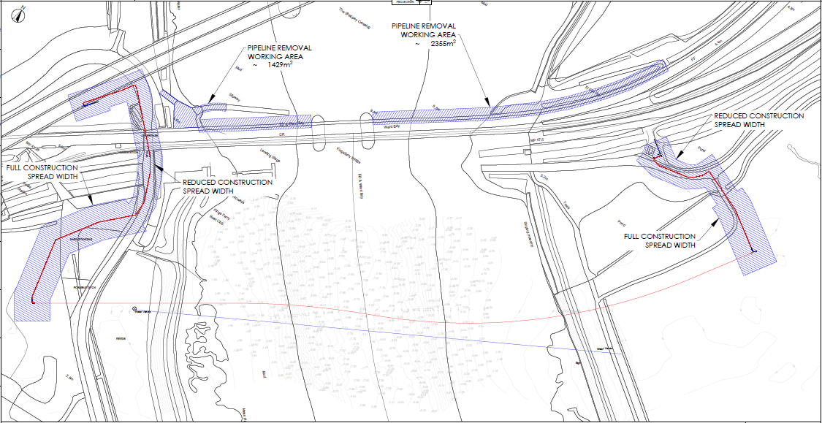
Figure 7 – Option 4 being the preferred option
  - Replacement Option 4 would utilise open cut trench works under the existing Kingsferry Bridge where a trench would be excavated under the structure. A new pipeline would be installed under the river Swale by HDD techniques, with the works areas extending in both directions to accommodate pipeline stringing and accommodation works. Upon completion, the Existing Pipeline within the Kingsferry Bridge would be decommissioned, and thereby require approval from Network Rail. However, Replacement Options 2 and 3 would involve drilling underneath operational railway assets to install any new pipeline, thereby posing increased risk of adversely affecting operational railway infrastructure, and hence managing the Project interface with Network Rail would from a technical perspective be significantly more complex.
Comparative Assessment of the four replacement route options
  - Having analysed each of the four replacement route options, Replacement Option 4 was considered by SGN to have fewer technical, land and environmental impacts than the other options considered. This option was consequentially described as the preferred solution in an Engineering Justification Paper dated July 2019 provided to OFGEM as part of SGN's GD2 funding submission. Option 4 was subsequently approved by OFGEM in December 2020.
  - SGN undertook a further comparative exercise to verify its decision to pursue Replacement Option 4. This involved all the outputs from the analysis of the replacement options being inputted into a relative risk review which was undertaken by SGN's engineering team and specialists. This involved each replacement route option being given a score relative to the other three replacement options. A scoring system was utilised to show the relative risk between the different route options. The relative risk was generally assessed as:
  - 1 – Low Risk
  - 2 – Medium Risk
  - 3 – Medium-High Risk
  - 4 – High Risk
 | Route Option
Route Risk | 1 | 2 | 3 | 4
Engineering Difficulty | 3 | 3 | 2 | 1
Construction Complexity | 4 | 3 | 2 | 1
HDD Risk | 3 | 2 | 3 | 1
Operational Complexity | 3 | 2 | 2 | 1
Industry Best Practice | 1 | 4 | 1 | 1
Risk of Drill failure | 4 | 3 | 3 | 1
Operational Risk | 3 | 2 | 2 | 2
Dewatering | 2 | 2 | 3 | 1
Environmental Consents | 3 | 4 | 4 | 4
Environmental Risk | 2 | 1 | 3 | 1
Land Rights Complexity | 4 | 2 | 3 | 1
Highways - Section 58 | 4 | 1 | 1 | 1
Impact on Flood Barriers | 4 | 4 | 4 | 4
Ecological Risk | 2 | 1 | 2 | 1
Archaeological consents | 2 | 3 | 4 | 3
Crown Consent Needed | 4 | 1 | 1 | 1
Agreement breach by 3rd party | 3 | 4 | 4 | 4
Land Risk | 4 | 2 | 3 | 1
Network Rail Consents | 3 | 3 | 3 | 1
Third Party Consents | 2 | 2 | 2 | 1
Cost | 4 | 2 | 3 | 1
Total Score | 64 | 51 | 55 | 33

  - In the comparative exercise, Replacement Option 4 came out on top overall, and in respect of 16 of the 21 comparative criteria considered.
Conclusion on Alternatives
  - All four replacement options contained degrees of engineering and construction complexity, likely designation impacts and consenting requirements. However, the outcome of the relative risk review which considered each replacement option, confirmed that the preferred option was Replacement Option 4 to the south of Kingsferry Bridge. This was because it was considered to be the most practical option to construct, would pose the least environmental impact on the surrounding area and deliver the most cost-effective viable route to connect into the existing pipeline network. It was this option that formed the basis of SGN's approved GD2 submission to Ofgem.
- Consents

  - The Project does not require planning permission under the Town and Country Planning Act 1990 Act (1990 Act) either because the relevant Works do not constitute development requiring planning permission under the 1990 Act or they benefit from permitted development rights under the Town and Country Planning (General Permitted Development) (England) Order 2015 (the GPDO).
  - Specifically, SGN is relying on its permitted development rights provided in Class A of Schedule 2, Part 15 of the GDPO.
  - By way of summary:
Project Component | Planning consenting position
Temporary construction areas & access | Permitted development pursuant to Class A of Part 4 of Schedule 2 of the GPDO
Decommissioning of Existing Pipeline | Not development under section 55 of the 1990 Act.
Construction of New Pipeline | Permitted development pursuant to Class A of Part 15 of Schedule 2 of the GPDO

Environmental Impact Assessment and Habitats Assessment
  - Due to the location of the Project in a sensitive area, SGN was required to carry out a screening for an Environmental Impact Assessment for this project pursuant to the Gas Transporter Pipeline Works (Environmental Impact Assessment) Regulations 1999 (1999 Regulations). This has been completed in accordance with the Regulations and a negative determination was issued on 9 May 2023 by the Department for Energy Security and Net Zero, confirming that no environmental assessment is required.
  - The Project is located within or in proximity to the following designated sites:
    - Medway Estuary and Marshes SSSI;
    - The Swale SSSI;
    - The Swale Ramsar;
    - The Swale SPA;
    - Medway Estuary and Marshes Ramsar; and
    - Medway Estuary and Marshes SPA.
  - In accordance with the requirements of the Conservation of Habitats and Special Regulations 2017 (Habitats Regulations 2017) and the Town and Country Planning (General Permitted Development) (England) Order 2015, SGN cannot commence Works under the auspices of its permitted development rights until it has received written notification from Natural England that an assessment of the potential effects of the proposals on the features for which the European sites are designated has been undertaken.
  - A draft habitats assessment was submitted to both Swale Borough Council and the Secretary of State for the Department of Levelling Up, Communities and Housing (DLUHC) in two separate applications for an EIA screening opinion (which was ultimately granted by DESNZ under the 1999 Regulations). The screening request to Swale Borough Council was made in March 2022 and the submission to DLUCH was made in June 2022 following a non-determination of the screening opinion request by Swale Borough Council. In both instances, Natural England were consulted and confirmed that information for an appropriate assessment for the purposes of regulation 76 of the Conservation of Habitats and Species Regulations 2017 had been provided. The draft habitats assessment was also submitted to DESNZ in March 2023.
  - The draft habitats assessment determined that there would be no likely significant effects following an appropriate assessment. Several potential effects were identified at screening, including:
    - Direct degradation of habitats that support qualifying features through physical damage;
    - Indirect disturbance through visual and audio impacts as well as changes in air / water quality;
    - Disturbance / displacement of qualifying species from visual, noise, vibration and or lighting impacts;
    - Direct harm / mortality of qualifying species; and
    - Spread of non-native species.
However, the habitats assessment concluded that, with mitigation measures incorporated into the design, there would be no adverse effect on the integrity of the European sites.
  - Following confirmation of the construction commencement date, an updated version of the habitats assessment will be submitted to Natural England alongside the application for assent to undertake works within the SSSI. Natural England have an obligation to determine the SSSI application within 28 working days and as such SGN intends to make this submission a minimum of eight weeks prior to the commencement of construction to ensure a determination is obtained in a timely manner.
  - Given the engagement to date with Natural England on the habitats assessment, SGN, as the competent authority, are confident that any likely significant effects identified on the designated sites can be avoided following consideration of proposed mitigation measures. Further to the positive engagement with Natural England to date, Natural England submitted a helpful representation to the Secretary of State further to the making of the Order which sets out proposed operations which will in due course require their consent. SGN do not see any reason why these requirements cannot in due course be satisfied.
  - SGN approached Natural England to ascertain the cost of a District Level Licence (DLL) in respect of great crested newt mitigation for the Project. Natural England provided a quote for the Project which was valid for three months. The DLL would allow SGN and their appointed build contractors to undertake the construction works anticipated by the Project. It is unlikely that conditions to the DLL would be required beyond requirements to erect fencing at certain times of the year and/or traps to be set for certain periods at certain times. SGN do not foresee any reason why this requirement cannot in due course be satisfied.
  - In respect of other species, further surveys (over and above those completed to date) will be completed prior to construction to ensure compliance with species legislation, an approach that is normal practice in view of species mobility. This further survey works is to be completed at the appropriate times as set out in Natural England's guidelines prior to commencement of construction. Data from these surveys will inform the HRA screening and, if necessary, appropriate assessment and the SSSI Assent which will be secured from Natural England prior to construction.
  - SGN are confident that securing the above approvals from Natural England does not represent an impediment to the delivery of the Project. There have been no material changes to the Project that would introduce additional likely significant effects beyond those identified in the draft habitats assessment or that would necessitate a change in the conclusions reached under it. In addition, Natural England have previously confirmed through consultation that the Project is not EIA development in ecological terms.

Floodplains
  - The Swale is a tidal channel of the Thames Estuary and works either side of the Kingsferry Bridge would be in the floodplain (albeit the land is defended).
Archaeology
  - There are also known archaeological assets within the surrounding area but these are not assets on which Historic England would need to be, or are invited to be, consulted on. SGN are confident that these assets are not impacted by the proposed Development.
Traffic Management and Construction Environmental Management Plan (CEMP)
  - A CEMP has not been produced for this Project. Details on how construction traffic will be managed were included in the documentation submitted as part of the screening for an Environmental Impact Assessment and the methodology set out there in incorporated protocols as to how to ensure environmental protection would be considered during construction.
  - It is proposed by SGN that a Traffic Management Plan will also be produced by the appointed build contractor and shared with affected third parties. This will set out the measures which SGN shall take to manage the impact of its proposals on the local highway network, including along Ridham Dock Road. The Traffic Management Plan will also include a proposed programme setting out clearly any proposed highway restrictions and their timing and explain how any restrictions shall ensure highway impacts are, so far as reasonably possible, minimised.
  - The current draft habitats assessment will likely be amended once final details of the construction programme and methodology is known and this will be agreed with Natural England in line with the requirements for working within European sites / SSSI.

- Additional Consents

Pipeline Safety
  - SGN has a statutory obligation to make a notification under the Pipeline Safety Regulations 1996, six months prior to construction (Regulation 20). This notification will be made prior to the commencement of construction.
  - Part 15A(2)(a) of the GDPO requires that the local planning authority is notified at least 8 weeks prior to the construction of 'notifiable pipelines', defined as major accident hazard pipelines. The New Pipeline does not meet any of the definitions of a major accident hazard pipeline under Schedule 2 of the Pipelines Safety Regulations 1996 and therefore this condition on the permitted development rights does not apply to these works.
  - There are no specific requirements under SGN's Licence that it must comply with beyond having respect for matters of safety and having regard to the over-riding importance of safety in the undertaking of the Project.
Footpath diversions and stopping up
  - The Schedule of Interests that accompanies the Order refers to the acquisition of rights in plots across which there are routed a number of footpaths (ZR90, ZR88, ZS19 and ZS12).
  - The Project Works will not interfere with footpaths ZS12 or ZS19 or ZR88 and these footpaths will not need to be stopped up or diverted.
  - Footpath ZR90 crosses plots which will be used for drilling under the river Swale. SGN is confident that footpath ZR90 will not be affected by the Works with measures such as the placing of bog matts which can be employed to ensure that the footpath remains passable. Diversion of the footpath would not be appropriate given that the land in the surrounding area is marshy and would not be a suitable alternative. A temporary stopping up order of this footpath would only be required in circumstances where the Works would make the route impassable, which is not considered likely.
  - Kingsferry Boat Club have noted that they intend to make an application to divert footpath ZR88 and further information as to the extent of this diversion has been requested by SGN.
  - For an 8-week period, SGN will need to secure a traffic regulation order to impose access restrictions along Ridham Dock Road to facilitate drilling operations for the new pipeline. Outside of this 8-week period, traffic management controls will be in place to regulate vehicle movements. Further detail is provided in section 16 of this Statement.
  - SGN's Project, and proposed traffic measures, will not at any time lead to access to any third-party land being prevented. During the short 8-week period during which SGN will seek to impose access restrictions along Ridham Dock Road via a traffic regulation order, alternative and unimpeded access to properties via Swale Way will be available.
  - When Southern Water Services (Southern Water) recently undertook nearby water pipeline replacement works, it is of note the water undertaker's works resulted in access restrictions along Ridham Dock Road for an eleven month period between October 2022 and August 2023. Due to the far shorter 8-week period during which SGN requires to restrict access along the same highway, it is not considered the requirement for a TRO poses an impediment to the delivery of the Project, and nor will the effect of access restrictions along Ridham Dock Road impose an unreasonable burden on third parties.
- New rights Acquired
  - SGN is taking a proportionate approach to compulsory acquisition and, rather than seeking to acquire the freehold title, is only seeking to acquire new rights over the Order Land. The new rights sought have been separated into 'packages' based on their purpose and applied to specific plots, as appropriate. The rights packages have been tailored in this way to ensure that a proportionate approach is taken, and the impact for affected landowners and occupiers is limited so far as reasonably practicable. Accordingly, if a plot is only required in order to facilitate limited works, the relevant rights package is sought in relation to that land.
  - The rights packages are defined in full in the Order but may be summarised as follows:
Name of Rights Package | Rights
Pipeline Construction Rights | All rights necessary for the purposes of or incidental to the construction of the New Pipeline and associated infrastructure / apparatus / equipment.
Pipeline Rights | All rights necessary to access the Order Land at all times with or without vehicles, plant and equipment for purposes associated with Decommissioning Rights and a full right of shelter and protection and vertical and lateral support for the benefit of the New Pipeline and associated infrastructure / apparatus / equipment from the land.
Working Area Rights | All rights necessary to erect, create, use and vacate a working area for the purposes of or incidental to the construction of the New Pipeline and associated infrastructure / apparatus / equipment or the decommissioning of the Existing Pipeline and associated infrastructure / apparatus / equipment
Access Rights | All rights necessary at all times to access the land and adjoining land with or without vehicles, plant, machinery, apparatus, equipment, materials and personnel for the purposes of the Decommissioning Rights, relocation of species identified in surveys and accessing the foreshore and erecting temporary scaffolding.
Decommissioning Rights | All rights necessary to decommission the Existing Pipeline and associated infrastructure / apparatus / equipment on the land.
Drilling Rights | All rights necessary for the purposes of or incidental to the construction of the New Pipeline and associated infrastructure / apparatus / equipment and rights.

- Acquisition by Agreement
Engagement Strategy
  - The Schedule to the Order identifies all those persons with an interest in the Order Land. In accordance with the CPO Guidance, SGN has sought to engage constructively in meaningful discussions with all known owners and occupiers of the Order Land, with a view to acquiring the new rights needed for the Project by agreement wherever possible.
  - Contact referencing commenced in July 2021 (and then again in 2023) whereafter a program of landowner engagement commenced with each landowner and/or their professional advisors as set out in the Schedule of Engagement at Appendix 1.
  - Negotiations to acquire the new rights in land needed for the Project are being carried out by Dalcour MacLaren, acting on behalf of and managed/instructed by SGN.
  - Throughout the engagement period, SGN and Dalcour MacLaren have taken time to explain SGN's land requirements, kept landowners appraised of the Project's progress/programme, and considered feedback received. Full details of Dalcour MacLaren's concerted efforts to engage with affected landowners is set out in the schedule of engagement at Appendix 1.
  - The majority of landowners understand the requirement for the Project and no objections have been raised to Dalcour MacLaren about the Project itself.
Progress to Date
  - With regard to the new rights that SGN is seeking to secure over the land coloured blue on the Order Map, Dalcour MacLaren have been engaging with landowners and their agents since July 2021 through Requests for Information surveys (RFIs), written correspondence, telephone discussions and site meetings. The engagement is ongoing and will include, as necessary, any newly identified landowners through ongoing RFIs.
Current position on land negotiations
Number of Interest Holders | 14
Heads of Terms agreed | 10
Option agreements exchanged | 6

  - Heads of Terms have been agreed with all landowners except:
    - Outback UK Propco I A Limited;
    - Kevin Witt, Steven John Moss, Dennis Frank Hills and Nicholas Crittenden (together forming the Kingsferry Boat Club);
    - Network Rail Infrastructure Limited; and
    - Stephen William Attwood, Lilian Joyce Attwood and James Frank Attwood (together the Attwoods).
  - Negotiations are ongoing with Outback UK Propco I A Limited and the Kingsferry Boat Club.
  - SGN has not negotiated terms with Network Rail on account of the NR Licence, nor has SGN negotiated terms with the Attwoods who have sold their interest to EJN Property Investments Limited (the transfer has not as at the date of this Statement of Case been registered at HM Land Registry).
  - SGN acknowledges that eight objections have been received to the making of the Order. However, land rights are only required from three of the objectors (Objection 2, Objection 3 and Objection 4 as noted at paragraph 16.2 of this Statement of Case), as those objectors are plot owners. SGN is seeking to enter into a joint agreement with Outback UK Propco I A Limited and Knauf (UK) GmbH as those objections relate to the same plot numbers. Objection 1 and Objections 5-8 relate to Table 2 interest holders and SGN does not believe that land rights are required to satisfy those objections. SGN provides its detailed response to each objection at section 16 of this Statement of Case.
  - SGN is committed to securing the land rights necessary for the Project by voluntary agreement if at all possible and is continuing to progress negotiations with landowners and occupiers as quickly as possible. However, despite all these efforts, SGN has not yet secured all the interests in the Order Land that it requires for the delivery of the Project. To provide certainty that the rights required for the Project can be assembled within a reasonable timeframe to enable the Project to be delivered, it is necessary for SGN to advance the CPO process in parallel with private treaty negotiations. Running the CPO process in parallel with continuing landowner negotiations is expressly envisaged by paragraph 17 of the CPO Guidance and SGN remains fully committed to progressing negotiations throughout the CPO process to acquire rights in land by agreement, where possible. This includes, where required, the eight landowners and occupiers who have made objections to the Order referred to in section 16 of this Statement of Case.
Network Rail Licence
  - SGN has the NR Licence in place with Network Rail which regulates the framework for the decommissioning of SGN's pipelines and which applies to the decommissioning of the Existing Pipeline. The NR Licence obligations are triggered upon SGN giving Network Rail not less than 12 months' prior written notice expiring on the anniversary of 1 January 2009. Assuming assumptions around programme for the installation of the New Pipeline are met, SGN currently anticipates serving notice to expire on 1 January 2027. Prior to expiry of that notice SGN must:
    - remove the relevant pipeline; and
    - execute any works for the protection of the railway as Network Rail require; and
    - comply with Network Rail's engineering conditions (being such conditions as Network Rail may properly require for the safety, protection or operation of its railway) and/or pipeline conditions, which require (amongst other things):
      - Network Rail's prior written approval to the commencement of the works;
      - SGN pre-planning entry onto Network Rail's land as far in advance as possible before hand;
      - any works to be carried out to Network Rail's satisfaction and (if required) under its supervision; and
      - compliance with any such stipulations, directions and requirements as Network Rail shall prescribe.
  - SGN has been engaging with Network Rail's ASPRO team since 22 August 2023 when it formally submitted an Asset Protection Initial Enquiry Questionnaire in respect of the Project. SGN received a response from Network Rail's Scheme Interface Manager on 13 October 2023, following which SGN attended a meeting with Network Rail personnel on 27 October 2023 to explain the Project in detail. This led to approval of a BAPA on 12th January 2024.
  - SGN is now in the process of sharing SHP files with Network Rail ahead of arranging a meeting with Network Rail's property surveyor and relevant internal stakeholders. It is envisaged all Network Rail concerns regarding impact on their assets will then be capable of being suitably addressed in an asset protection agreement.
Southern Water
  - Southern Water have apparatus in the Order Land. As at the date of this Statement, SGN is engaging with Southern Water to secure the necessary Asset Protection Agreement to secure removal of Southern Water's objection.
- Other assistance and commitments provided to landowners
  - SGN has taken steps to try to help owners and occupiers understand the Project and the effect of the Order in addition to seeking to acquire land rights by negotiation. SGN and its agent, Dalcour MacLaren, remain open to providing affected landowners with such further clarification of the Project or aspects of the Order as they may reasonably require.
- Special Category and Statutory Undertakers Land
Land belonging to statutory undertakers
  - The Order Land includes land owned by the following statutory undertakers:
    - Network Rail own parts of plots 31, 32, 33, 34, 35, 54, 55, 62, 64, 69;
    - Network Rail own plots 37, 38, 39, 40 in respect of mines and minerals;
    - National Highways Limited own plots 2, 3, 4, 5, 6, 7, 8, 9, 10, 12, 13, 15, 16, 17, 18, 19, 20, 21, 22, 23, 25, 30, 53, 62;
    - Kent County Council own plots 9, 11, 13, 14, 20, 22, 24, 26, 27, 28, 29, 30, 31, 32, 34, 54, 55, 58, 59, 60, 61, 62, 69.
Land belonging to a local authority
  - Whilst there is public highway within the Order Land (the status of which is unaffected by the Order), the Order Land does not otherwise include any land which is owned by a local authority.
Land owned by the National Trust
  - The Order Land does not include any land which is owned by the National Trust.
Land forming part of a common, open space or a fuel or field garden allotment
  - The Order Land does not include any common land, open space or fuel or field garden allotments.
Burial grounds, ecclesiastical property or land which includes listed buildings or is in a conservation area
  - The Order Land does not include any burial grounds, listed buildings or conservation areas within the Order Land.
Crown Land
  - The Order Land does not include any Crown Land.

- Mining Code
  - The mining code in Parts 2 and 3 of Schedule 2 of the Acquisition of Land Act 1981 is to be included within the Order in respect to the land shown coloured blue on the Order Map. The rights that SGN is seeking pursuant to the Order will not interfere with any mining and minerals rights over such land and so the mining code is being included for the purposes of asset protection i.e. to ensure that SGN's apparatus and equipment are adequately safeguarded and protected in the future.

- Funding and Delivery
Funding
  - The options for the replacement of the Existing Pipeline were presented to OFGEM for its current RIIO-GD2 price control period to 31 March 2026. Replacement Option 4 was subsequently approved by OFGEM in December 2020 as a named project within the RIIO-GD2 price control agreement. The allowances provided by OFGEM are available from 1 April 2021 to 31 March 2026, but shall remain available to SGN beyond that period to complete the Project..
  - SGN is investment grade rated by S&P, Fitch, and Moody’s (rated BBB (stable), BBB+ (stable) and Baa1 (stable) respectively), demonstrating that SGN has the credit strength to deliver the project. The Project and subsequent application for the Order has already been GD2 Ofgem pre-funded.
  - SGN's strong credit rating, coupled with Ofgem RIIO-2 determination in respect of the Project, means the requisite funding is available to meet the implementation and land acquisition/compulsory purchase costs associated with the Project as and when required (including any advance payments).
Delivery
  - SGN’s Network Investment Committee granted internal approval to progress with the Project and allocated appropriate funding and financial management in May 2023 via SGN's governance process.
  - To secure contractor resources for the Project, SGN will undertake a competitive procurement event from a preferred list of suppliers. The successful contractor will then undertake the works.
  - The construction periods for site activities will be influenced by the mitigatory actions agreed within the habitats assessment and associated documentation to provide for protection of the local ecology and environment. Subject to the progress and conclusion of the Order, SGN anticipates a start date for the on-site pre-construction activities in October 2024 with compound works construction commencing in February 2025. Completion of these works will enable the installation of the new pipeline and connections to the Existing Pipeline from August 2025 with completion in October 2025.
  - The decommissioning of the Existing Pipeline within the structure and service tunnel of Kingsferry Bridge will commence after installation and commissioning of the New Pipeline has taken place in November 2025 with decommissioning anticipated to be completed in March 2026.
  - As such, paragraphs 13 and 14 of the General Overview of the CPO Guidance are met.

- Human Rights and Equalities
  - Each plot of land described in the Order is required for the purposes of the Project, or is needed to facilitate, mitigate, or is incidental to the Project.
  - SGN is taking a proportionate approach to compulsory acquisition and, rather than seeking to acquire the freehold title to all of the Order Land, is seeking to acquire rights over the Order Land.
  - SGN has sought to acquire the rights in land which are required to deliver the Project through private treaty negotiations. Details of the negotiations to date are set out in the Schedule of Engagement at Appendix 1 of this Statement of Case.
  - With regards to human rights, Section 6 of the Human Rights Act 1998 prohibits public authorities from acting in a way which is incompatible with rights protected by the European Convention on Human Rights (the Convention). The position is summarised in paragraph 12 of the General Overview of the Guidance, which states that a compulsory purchase order should only be made where there is, "a compelling case in the public interest". The Guidance makes it clear that an acquiring authority should be sure that the purposes for which it is seeking compulsory acquisition powers sufficiently justify interfering with the human rights of those with an interest in the land affected. In making this assessment, an acquiring authority should have regard to the provisions of Article 1 of the First Protocol to the Convention, and in the case of dwelling, Article 8.
  - Article 1 of the First Protocol states that:
"...Every natural or legal person is entitled to peaceful enjoyment of his possessions" and "no one shall be deprived of his possessions except in the public interest and subject to the conditions provided for by the law and by the general principles of international law...".
  - The Order Land is proposed to be affected by the acquisition of new rights only. The new rights sought by SGN have been separated into 'packages' based on their purpose and applied to specific plots, as appropriate. Some of the rights are only required for temporary purposes, such as the creation of construction compounds, and will only be exercised during the construction phase. Other rights will be permanent in nature, such as the right to install, operate, repair and maintain the new sections of pipeline. The rights 'packages' have been tailored in this way to ensure that a proportionate approach to compulsory purchase is taken, and that the impact for affected landowners and occupiers is limited so far as reasonably practicable.
  - The Order is being promoted in the public interest as required by Article 1 of the First Protocol and the public benefits have been set out in detail earlier in this Statement. SGN considers that the Order will therefore strike the right balance between the public interest in the implementation of the Project and those private rights that will be affected by the Order.
  - Article 6 of the Convention provides that:
"In determining his civil rights and obligations... everyone is entitled to a fair and public hearing within a reasonable time by an independent and impartial tribunal established by law."
  - The Order has been extensively publicised to those affected. All those affected by the Order will be notified, will have the right to make representations and objections to the Secretary of State, and objecting parties will have the right to be heard at a public inquiry. It has been held that statutory processes comply with Article 6 of the Convention.
  - Those whose interests are acquired under the Order will also be entitled to compensation which will be payable in accordance with the Compulsory Purchase Compensation Code. The Compensation Code has been held to be compliant with Article 8 and Article 1 of the First Protocol to the Convention.
  - SGN has sought to keep any interference with the rights of those with interests in the Order Land to a minimum. The land within the Order has been limited to the minimum required for the Project infrastructure to be installed, operated and maintained.
  - The requirements of the Human Rights Act 1998 and the Convention, particularly the rights of property owners, have therefore been fully considered. There is a compelling case in the public interest for the Order to be made and confirmed, and the interference with the private rights of those affected that would be the inevitable result of the exercise of compulsory purchase powers conferred by the Order would be lawful, justified and proportionate.
Equality Act
  - Whilst not directly subject to the public sector equality duty in section 149(1) of the Equality Act 2010, SGN has had regard to the public sector equality duty, and has, in promoting the Order, undertaken a landowner engagement exercise.
  - SGN has taken account of and considered receptors and effects on those receptors through its environmental assessment processes for the Project.
  - SGN does not currently consider that the Project will give rise to any impacts or differential impacts on persons who share a relevant protected characteristic as defined in the Equality Act, or upon persons who do not share such relevant protected characteristic. However, SGN's position will be continually monitored, and should any persons be identified who may be adversely impacted by the Project, packages of assistance measures will be put in place as necessary so as to mitigate so far as practicable any identified activity that may have an adverse impact on these individuals.

- Statement justifying extent of scheme for no-scheme world
  - Section 6(A) of the Land Compensation Act 1961 (LCA 1961) provides that "the no-scheme principle is to be applied when assessing the value of land in order to work out how much compensation should be paid by the acquiring authority for the compulsory acquisition of the land". For the purposes of section 6(A), the "scheme" means the scheme of development underlying the acquisition.
  - Section 6 explains that the underlying scheme is to be the scheme provided for by the Order unless it is shown that the underlying scheme is a scheme larger than, but incorporating, the scheme provided for by that instrument.
  - The Order authorises the compulsory acquisition of land and rights needed for the Project. The Project is the "scheme" for the purposes of section 6(A).

- Objections to the Order
  - The statutory notices advised that any objections to the Order must be in writing stating the title of the Order and the grounds of objection and addressed to the Secretary of State for Energy Security and Net Zero, Energy Infrastructure Planning Delivery Team, 3-8 Whitehall Place, London, SW1A 2HH by 15 November 2023.
  - A total of eight objections were made to the Order as follows:
    - Objection 1: Southern Water in respect of Plot Nos. 1-4, 6, 7, 9-14, 16, 17, 20-27, 32, 34, 36-44, 47, 48, 53, 54, 57, 59, 62, 64-67, 69-80 and 83;
    - Objection 2: Network Rail Infrastructure Limited in respect of Plots Nos. 31-35, 37-44, 48, 49, 54, 55, 62, 64, 69 and 70;
    - Objection 3: Outback UK Propco I A Limited in respect of Plot Nos. 34-36 and 46;
    - Objection 4: Knauf (UK) GmbH in respect of Plot Nos. 36 and 46;
    - Objection 5: Countrystyle Recycling Ltd in respect of Plot Nos. 36 and 46;
    - Objection 6: Grovehurst Energy Limited (subsidiary of D.S. Smith Group) in respect of Plot Nos. 36 and 46;
    - Objection 7: Manweb Nomineeco Limited (Manweb) in respect of Plot Nos. 36 and 46; and
    - Objection 8: Ridham Sea Terminals Limited in respect of Plot Nos. 36 and 46.
  - It should be noted that objections 3 – 8 essentially make the same points to different degrees, in relation to the maintenance of access to their interests for the duration of the Works affecting Ridham Dock Road.
  - SGN has responded to each objector individually in writing and remains committed to reaching an agreed position with each of these landowners. The most recent correspondence with all objectors is a letter dated 18th January 2024 in which SGN's agents, Dalcour MacLaren have offered to arrange a meeting to discuss the Project and its impact upon the respective objector's interests. The grounds of each objection that have been raised and SGN's response to these may be summarised as follows:
(Southern Water (Objection 1) and Network Rail (Objection 2) - Statutory Undertaker apparatus is located within proximity to the Project works
  - Network Rail and Southern Water have assets and apparatus located within proximity to the Project works and this ground has been raised on the basis that their assets and apparatus may be adversely affected by the Project works.
  - SGN is in the process of negotiating the relevant agreements to ensure that Network Rail's and Southern Water's assets are sufficiently protected to enable them to withdraw their objections to the Project.
  - Southern Water has also expressed concern that SGN's Project may affect access to its Queenborough Wastewater Treatment Works. However, as explained to Southern Water following receipt of their objection, access to that facility is not impacted by the Project.
Outback Uk Propco I A Ltd (Objections 3)
  - Outback has expressed concern in relation to the acquisition of rights by SGN under the Order affecting their ability to use Ridham Dock Road. Outback has expressed concern that this could impede access to their property due to ongoing works being undertaken at two junctions of the A249 to the West of Sittingbourne. SGN understand this work relates to a £38.1million highway improvement project being undertaken by Kent County Council (KCC), and not (as referenced by some objectors) National Highways. Outback has requested further details as to how the Project will interface with KCC's works, and this has now been provided to Outback.
  - KCC's A249/Grovehurst Road improvement works are being constructed by KCC's contractor, Jackson Civil Engineering and comprise:
    - replacing the existing 'dumbell' junction with a two-bridge flyover; and
    - removing the current roundabouts and constructing an additional bridge to create a loop over the A249.
  - SGN has been provided by Chris Williams, the site agent who is project managing the highway works on behalf of Jackson Civil Engineering for KCC with a planned phasing of the KCC works. Appendix 2 comprises a table which briefly summarises each phase of the works together with associated drawings. This table also provides the associated timeline for the delivery of each phase and an explanation as to how each phase of the KCC works will affect access to Swale Way from the A249.
  - Appendix 2 (which has been agreed by Jackson Civil Engineering) establishes that access to Swale Way from the A249 will only be affected by 3 phases of this KCC project:
    - Phase 2B (Southbound Off Slip +Gyratory South) scheduled to be undertaken in the period August – December 2024;
    - Phase 1B (Gyratory Southern Spur) scheduled to be undertaken in the period November 2024 – January 2025; and
    - Phase 3B (Segmental Road Closure) scheduled to be undertaken in April 2025.
  - Throughout Phases 2B and 1B, temporary asphalt will be laid to provide a carriageway around the works controlled by two-way traffic lights which will enable traffic to pass in each direction throughout the works outlined in these two phases. Phase 3B will involve a full road closure for the one-month period, but a signed diversion will be in place which shall provide continued access to the Ridham Dock Industrial Estate and other business and industrial locations.
  - The highway improvement works are currently underway and are currently aligned with the dates provided in Appendix 2.
  - The planned Project works for the replacement of the gas main across the river Swale requires Ridham Dock Road to be closed in early September 2025 for eight weeks. Appendix 2, which outlines the timeline for KCC’s phased highway improvement works, makes clear that these are due to be completed some four months earlier than the planned Project works, by May 2025.
  - Based on the information provided by Jackson Civil Engineering, SGN can therefore confirm access along Ridham Dock Road will not be restricted by SGN to facilitate works for the Project concurrently with the highway improvement works being undertaken by KCC to the B2005 (Grovehurst Road) and A249 junction. Continued access to the various business park and industrial complexes which ordinarily have the benefit of highway access via Ridham Dock Road will be always available along Swale Way from the A249, which will not be impacted by KCC undertaking highway improvement works during the period of closure of Ridham Dock Road.
  - In addition SGN note that whilst Outback UK Propco I A Ltd and Knauf (UK) GmbH own the privately maintained part of Ridham Dock Road over which SGN seeks to acquire rights, SGN shall be required to obtain a traffic regulation order to secure the necessary access restrictions along the publicly maintainable section of Ridham Dock Road to facilitate its Project. It is highly unlikely that the local authority would be willing to make a temporary traffic regulation order which facilitated access restrictions on Ridham Dock Road at a time when access is unavailable to affected properties and businesses from the A249. Notwithstanding the protection afforded by the requirement to secure a traffic regulation order, SGN would be prepared to undertake not to implement any access restrictions on Ridham Dock Road unless and until the KCC works to improve the B2005 (Grovehurst Road) and A249 junction no longer pose an impediment to access for vehicles along Swale Way.
  - Throughout the SGN works, SGN’s project manager will continue to liaise closely with the affected stakeholders on a regular basis to ensure they are all aware of progress and delivery against SGN's programme.
Knauf (UK) GmbH (Objection 4)
  - Knauf (UK) GmbH has, like Outback, also expressed concern in relation to the acquisition of rights by SGN under the Order affecting its ability to use Ridham Dock Road. SGN relies on its response to Outback's objection at paragraphs 16.8-16.17 above for its response to Knauf's objection.
Countrystyle Recycling Ltd (Objection 5)
  - Countrystyle Recycling Ltd has, like Outback and Knauf, also expressed concern in relation to the acquisition of rights by SGN under the Order affecting their ability to use Ridham Dock Road. SGN relies on its response to Outback's objection at paragraphs 16.8-16.17 above for its response to Countystyle Recycling Ltd's objection.
Manweb Nomineeco Limited (Objection 6)
  - Manweb does not object to the principle of the Project but has also expressed concern in relation to the acquisition of rights by SGN under the Order affecting its ability to use Ridham Dock Road. SGN relies on its response to Outback's objection at paragraphs 16.8-16.17 above for its response to this part of Manweb's objection.
  - In addition, SGN note that Manweb has referred to the impact of the Project on Ridham Dock Road itself (not just in conjunction with KCC's highway works), and there being no alternative means of access or proposals for access during construction of the Project for Manweb and the tenants of its property. SGN note that throughout any period of restricted access along Ridham Dock Road, alternative access to properties will always be available to the south via Swale Way, and hence during any short period of restricted access along Ridham Dock Road there shall at all times be a suitable alternative access available to Manweb and its tenants (as was the case during the recent (far longer) 11 months of restricted access along Ridham Dock Road caused by Southern Water's pipeline replacement project).
  - Manweb express concern that at no time has SGN sought to afford Manweb an opportunity to comment on the Order prior to its making and/or discuss whether a solution could be found (e.g. an agreement for temporary use and works) that would ensure continuity of access to its property. SGN however again reiterate that suitable access to Maweb's property will at all times be available during any period of restricted access along Ridham Dock Road, and notes this will be for a far shorter programmed period than was the case with the recent access restrictions imposed as a result of Southern Water's pipeline replacement project.
  - Manweb also assert that SGN has failed to consider alternatives such as temporary use and works. However, SGN has carefully considered alternatives and the package of rights its requires to secure the Project. A short period of access restrictions is necessary to ensure the essential pipeline replacement works can safely and efficiently proceed, but these shall be carried out in careful consultation with affected third parties to mitigate the transportation impact of the Project on highway users.
Grovehurst Energy (Objection 7)
  - Grovehurst Energy's objection is predicated on closure of what it calls the "spine road", thereby exacerbating traffic issues to its operations, especially with other traffic works in the area.
  - In response to Grovehurst Energy's objection, SGN reiterates its response to the objection made by Outback at paragraphs 16.8-16.17 above, and Manweb at paragraphs 16.20-16.23.
Ridham Sea Terminals Limited (Objection 8)
  - Ridham Sea Terminals objection notes that both routes it describes as the W and S Routes are in regular use and it is imperative that both routes remain open at all times, and that the rights sought under the Order, which would entail access restrictions along Ridham Dock Road (thereby affecting the W route) are fundamentally at odds with that necessity.
  - Ridham Sea Terminals also express concern as to the risk of delays to the Project and that any form of access restriction along Ridham Dock Road may have substantial and detrimental impact on its business operations, its undertenants and other operators at Ridham Dock.
  - Ridham Sea Terminals request that either Route W always remain open, or an alternative suitable means of access be provided by SGN to its property, thereby alleviating the impact of the Project on its operations.
  - In response to Ridham Sea Terminals objection, SGN reiterates its response to the objection made by Outback at paragraphs 16.8-16.17 above. In addition, SGN reiterate that it was recently the case that access was restricted along Ridham Dock Road to facilitate Southern Water's pipeline replacement project for a far longer 11-month period, as opposed to the short 8-weeks of access restrictions which SGN will require to facilitate the Project. Affected businesses, including Ridham Sea Terminals, continued to operate throughout Southern Water's period of access restrictions due to access being available at all times from the south and Swale Way off the A249. This would similarly be the case during any period of restrictions required by SGN.
Natural England
  - A representation was also received from Natural England which stated that Natural England do not object to the Order in principle but notes the operations that require prior consent before they can take place on SSSIs. SGN has noted the helpful observations of Natural England, and refer to section 6 of this Statement which provides a response to the points raised.

- Further Information
Negotiation of acquisitions
  - Owners and occupiers of land affected by the Project who wish to negotiate a voluntary agreement or discuss matters of compensation should contact SGN's appointed land agents, Dalcour MacLaren by telephone on 0331 885374 or in writing to Dalcour Maclaren, Unit 1, Staplehurst Farm, Weston-on-the Green, Bicester OX25 3QU or by email to Kingsferry@dalcourmaclaren.com
Compensation
  - Provision is made by statute with regard to compensation for the compulsory acquisition of land and the depreciation in value of properties. More information is given in the series of booklets published by the Department for Housing, Communities and Local Government entitled "Compulsory Purchase and Compensation" listed below:
- Booklet No. 1 - Compulsory Purchase Procedure.
- Booklet No. 2 - Compensation to Business Owners and Occupiers.
- Booklet No. 3 - Compensation to Agricultural Owners and Occupiers.
- Booklet No. 4 - Compensation for Residential Owners and Occupiers.
  - The booklets are available to download for free online at: www.gov.uk/government/collections/compulsory-purchase-system-guidance
- Evidence and Core Documents
  - In view of the above objections, SGN presently intends to call witnesses to the inquiry on the following issues:
    - to provide a technical description of the Works, explain the need for the Project, alternatives and the classes and extent of the rights sought in the Order;
    - third party landowner engagement and efforts to acquire rights by agreement; and
    - interaction of the Project with Network Rail's and Southern Water's interests.
  - SGN reserves its right to submit evidence in relation to further matters in the event that it is necessary to do so.
  - A Core Documents List is at Appendix 3 of this Statement.
  - SGN reserves its right to amend the Core Documents List as necessary.

- Conclusions
  - SGN has made the Order under section 9 of, and Schedule 3 to, the 1986 Act, and having regard to the CPO Guidance. If confirmed by the Secretary of State, the Order will authorise SGN to purchase compulsorily the new rights in land required for the Project.
  - As set out in this Statement, the Project is required primarily to secure security of supply of gas to the Isle of Sheppey, and is fully supported by national energy policy.
  - The requirements of the Human Rights Act 1998 and the Convention, particularly the rights of property owners, have been fully taken into account, along with considerations pertinent to the Equalities Act 2010. The interference with the private rights of those affected would be lawful, justified and proportionate.
  - The public benefits of the Project substantially outweigh the private interests affected, which SGN has sought to minimise by acquiring rights over the Order Land, rather than freehold interests. Additionally, in order to ensure a proportionate approach is taken to the acquisition of rights, SGN is only seeking the particular rights that it needs in relation to each plot, rather than adopting a blanket approach across all of the Order Land.
  - All requisite planning is in place for the Project and there is no reason known to SGN why other consents/licences required for the Project should not be granted. As such there are no physical or legal impediments to the implementation of the Order.
  - There is a compelling case in the public interest for the confirmation of the Order.
  - The Secretary of State should confirm the Order accordingly.

Southern Gas Networks PLC
18 January 2024

- Appendices
  - Appendices to this Statement:
    - Appendix 1: Schedule of Landowner Engagement
    - Appendix 2: Works to B2005/Grovehurst Road and A249 junction being undertaken by KCC
    - Appendix 3: Core Documents List

Appendix 1
Schedule of Engagement

Plot | Plot Owner | Status of Negotiations
1; 19; 53 | John Nicholas Plumptre | Negotiations commenced in March 2022. Heads of Terms were agreed on 1 August 2022 and an option agreement for the grant of a licence was exchanged on 22 August 2023.
2; 3; 4; 5; 6; 7; 8; 9; 10; 12; 13; 15; 16; 17; 18; 19; 20; 21; 22; 23; 25; 30; 53; 62 | National Highways Limited | Negotiations commenced in July 2021 and Heads of Terms were agreed on 5 August 2022. Documents have been issued to National Highways Limited's solicitors and negotiations on the final form of documentation are ongoing.  The latest correspondence between the project and National Highways Limited was an e-mail from SGN's solicitors to National Highways Limited's in-house solicitor on 16 January 2024.
9; 11; 13; 14; 20; 22; 24; 26; 27; 28; 29; 30; 31; 32; 34; 54; 55; 58; 59; 60; 61; 62; 69 | Kent County Council | Negotiations commenced in July 2021. Heads of Terms were agreed on 4 August 2022 and an option agreement for the grant of rights was exchanged on 10 March 2023.
19; 53; 54; 56 | Queenborough Fishery Trust | Negotiations commenced in July 2021. Heads of Terms were agreed on 31 May 2022 and an option agreement for the grant of rights was exchanged on 27 April 2023.
37 | Kevin Witt  Steven John Moss  Dennis Frank Hills  Nicholas Crittenden | A site meeting took place on 25 September 2023 and Heads of Terms were issued on 10 October 2023.  The latest correspondence between the project and the Plot Owner was an e-mail from Dalcour MacLaren to the Plot Owner's agent on 12 January 2024.
34; 35; 36; 46 | Knauf UK GMBH | Negotiations commenced in July 2021 alongside the joint landowner, Dooba Investments III Limited and Heads of Terms were agreed on 20 July 2022. Documents have been issued to Knauf UK GMBH's solicitors and negotiations are ongoing following Outback UK Propco I A Limited's purchase of Dooba Investments III Limited's interest in the property.  The latest correspondence between the project and the Plot Owner was a letter from Dalcour Maclaren dated 17 January 2024.
34; 35; 36; 46 | Dooba Investments III Limited  Outback UK Propco I A Limited | Negotiations commenced in July 2021 alongside the joint landowner, Knauf UK GMBH and Heads of Terms were agreed on 20 July 2022. Documents were issued to Dooba Investments III Limited's solicitor and negotiations were ongoing. Dooba Investments III Limited have subsequently sold their interest in the property to Outback UK Propco I A Limited.  Negotiations with Outback UK Propco I A Limited are ongoing and revised Heads of Terms were circulated by Outback UK Propco I A Limited's solicitor on 9 October 2023.  Outback UK Propco I A Limited's solicitors requested more information on 13 November 2023 regarding junction improvement works being carried out to the A249 which have the potential to impact their access to their industrial estate. The industrial estate is also accessed over plots 34, 35, 36 and 46 and Outback UK Propco I A Limited's objection letter was predicated on ensuring access to the industrial estate.  The further information requested by Outback UK Propco I A Limited's solicitors was provided by SGN's solicitors in an email dated 15 January 2024, with the latest correspondence between the project and the Plot Owner was a letter from Dalcour Maclaren dated 17 January 2024.
35; 38; 39; 40; 41; 42; 43; 44; 45; 47; 48; 49 | E.J. Mackelden & Sons (Bobbing) Limited | Negotiations commenced in July 2021. Heads of Terms were agreed on 15 July 2022 and an option agreement for the grant of rights was exchanged on 31 March 2023.
49; 50; 51; 57 | Port of Sheerness Limited | Negotiations commenced in October 2021. Heads of Terms were agreed on 21 February 2022 and an option agreement for the grant of rights was exchanged on 31 March 2022.
51; 52; 78; 79; 80; 81; 82 | Stephen William Attwood  Lilian Joyce Attwood  James Frank Attwood  EJN’s Property Investments Limited | Through the land referencing process, it was identified that Stephen William Attwood, Lilian Joyce Attwood and James Frank Attwood have completed a transfer of their interest in the land to EJN’s Property Investments Limited.  Negotiations commenced with EJN's Property Investments Limited in July 2021 and Heads of Terms were agreed on 4 November 2021. Documents have been issued to EJN's Property Investments Limited's solicitors and negotiations on the final form of documentation are ongoing.  The latest correspondence between the project and EJN’s Property Investments Limited was an e-mail from SGN’s agents dated 16th January 2024.
63; 64; 65; 66; 67; 68; 72; 73; 74; 75; 76; 77 | EJN’s Property Investments Limited | Negotiations commenced with EJN's Property Investments Limited in July 2021 and Heads of Terms were agreed on 4 November 2021. Documents have been issued to EJN's Property Investments Limited's solicitors and negotiations on the final form of documentation are ongoing.  The latest correspondence between the project and EJN’s Property Investments Limited was an e-mail from SGN's agents dated 16 January 2024.
82; 83 | E.C.T. (Conservation) Limited | Negotiations commenced in August 2021. Heads of Terms were agreed on 17 August 2021 and an option agreement for the grant of a licence was exchanged on 23 September 2022.
31; 32; 33; 34; 35; 37; 38; 39; 40; 54; 55; 62; 64; 69 | Network Rail | SGN has the NR Licence which regulates the framework for the decommissioning of SGN's pipelines. The NR Licence obligations are triggered upon SGN giving Network Rail not less than 12 months' prior written notice expiring on the anniversary of 1 January 2009. Prior to expiry of that notice SGN must:  - remove the relevant pipeline; and  - execute any works for the protection of the railway as Network Rail require; and  - comply with Network Rail's engineering conditions (being such conditions as Network Rail may properly require for the safety, protection or operation of its railway) and/or pipeline conditions, which require (amongst other things):  - Network Rail's prior written approval to the commencement of the works;  - SGN pre-planning entry onto Network Rail's land as far in advance as possible before hand;  - any works to be carried out to Network Rail's satisfaction and (if required) under its supervision; and  - compliance with any such stipulations, directions and requirements as Network Rail shall prescribe.  SGN and Network Rail are in correspondence to agree the necessary asset protection provisions for the works.

Appendix 2

Works to B2005/Grovehurst Road and A249 junction being undertaken by KCC

Phase | Description of work | Timeline | Affects Swale Way Access
1a North Gyratory | - Earthworks  - Road constriction  - Diversion of Stats | 09/23 – 11/24 | No
1B South Gyratory | - Offline earthworks  - Drainage Runs  Diversion of Gas governor | 09/23 – 04/24 | No
New Bridge Construction | - Piling  - RC works | 09/23 – 12/24 | No
Developer Roundabout | - New road construction  - Stats diversion | 01/24 – 07/24 | No
1B Quadrant | - Offline Road Construction  - Diversion of stats into new footway  - Complete Road Construction | 08/23 – 06/24 | No
1B New Nicholls | - Offline Road Construction | 02/24 – 04/24 | No
1a Northbound on Slip + Gyratory | - Re-alignment of slip road | 09/23 – 11/24 | No
2G Northbound Off Slip Widening | - Drainage  - Road works | 09/23 – 06/24 | No
1B Nicholls/North Pond | - Construction of new pond | 09/23 – 06/24 | No
2B Southbound Off Slip +Gyratory South | - New road Construction  - Major Earthworks | 08/24 – 12/24 | Yes – Two way traffic flow around works on temporary asphalt
1B Gyratory Southern Spur | - Cable Diversion  - New Drainage | 11/24 – 01/25 | Yes – Two way traffic flow around works on temporary asphalt
2G New Drainage Outfall from A249 | - Drainage | 09/23 – 02/24 | No
2F Southbound on Slip Widening | - Drainage  - Road works | 08/24 – 11/24 | No
2H Existing Roundabout Infilling | - Road works | 06/24 & 04/25 | No
Phase 3A New Gyratory Layout, Daytime Lane Closures | - Final infilling  - Landscaping | 04/25 – 05/25 | No
Phase 3B Segmental Road Closure | - Ties ins  - Overlay | 04/25 | Yes – Road Closures, Swale Way still accessible at all times
Note: Offline Road Construction means no road/lane closures during this phase

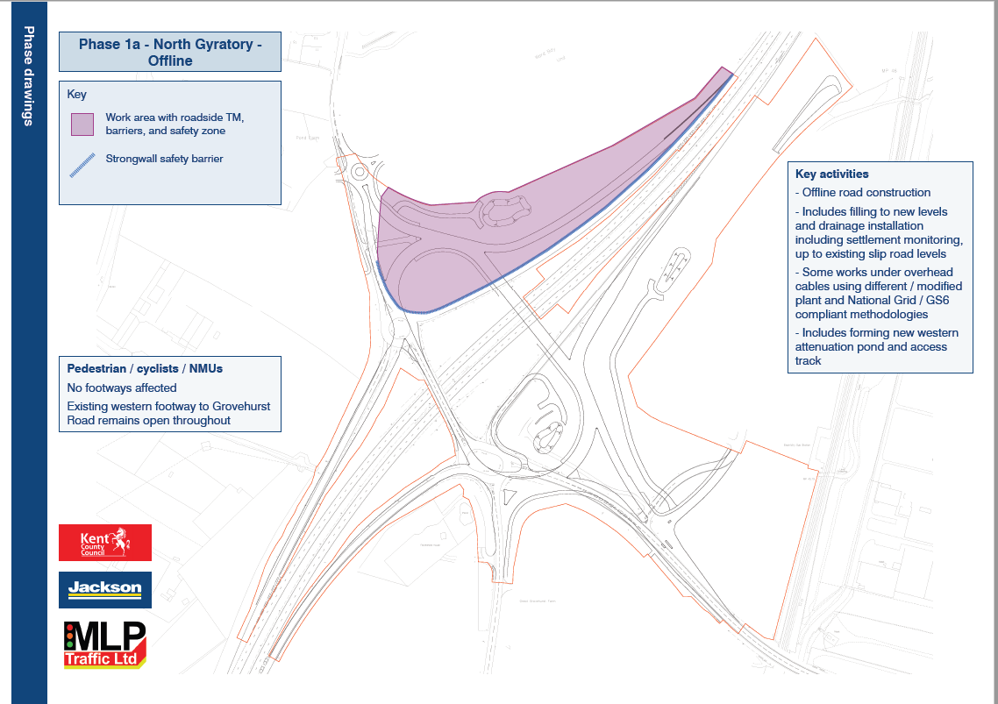
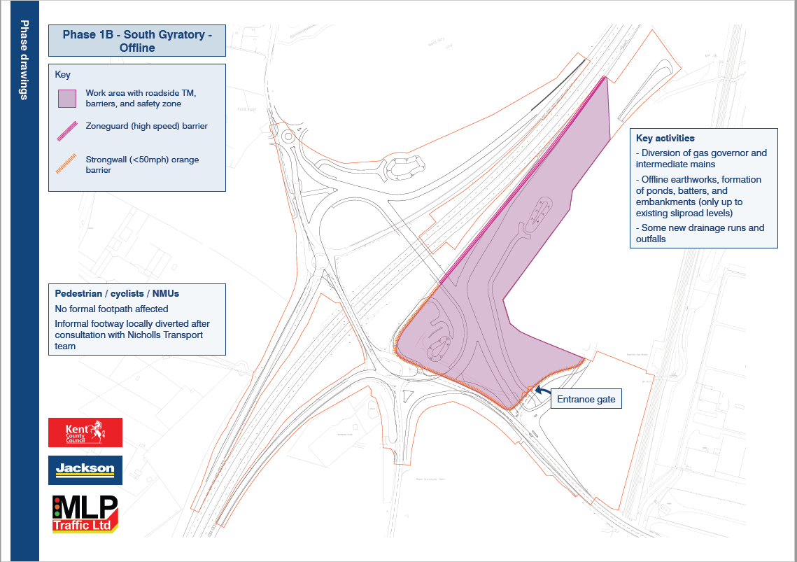
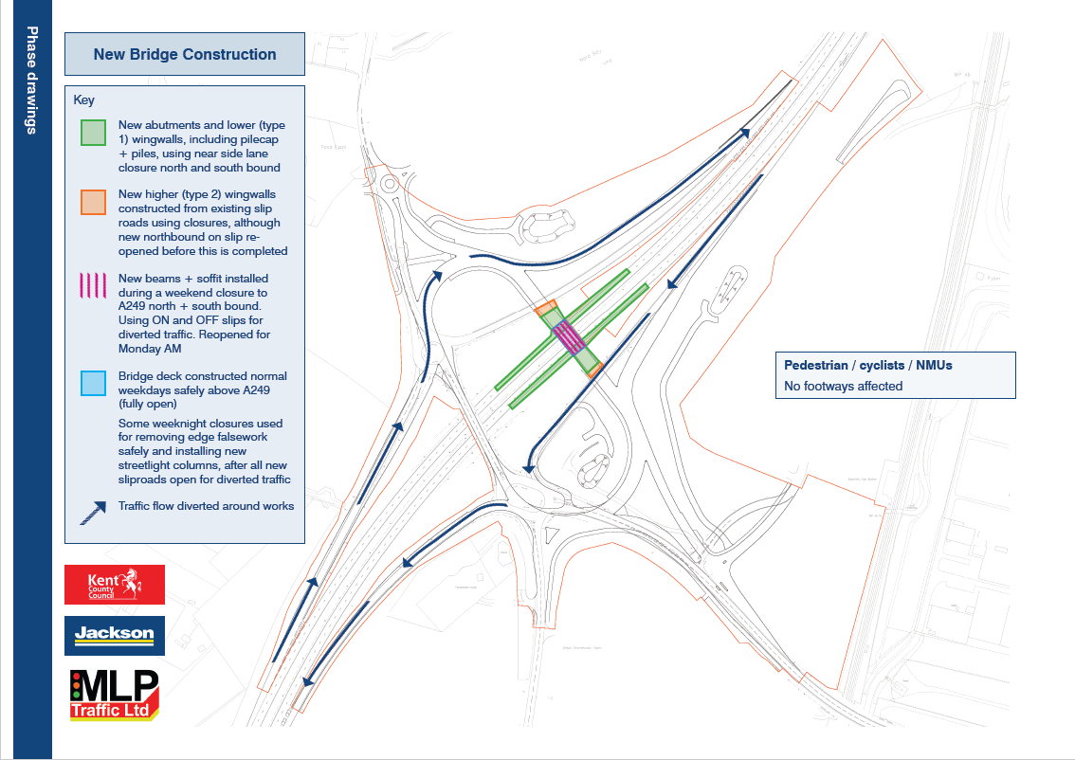
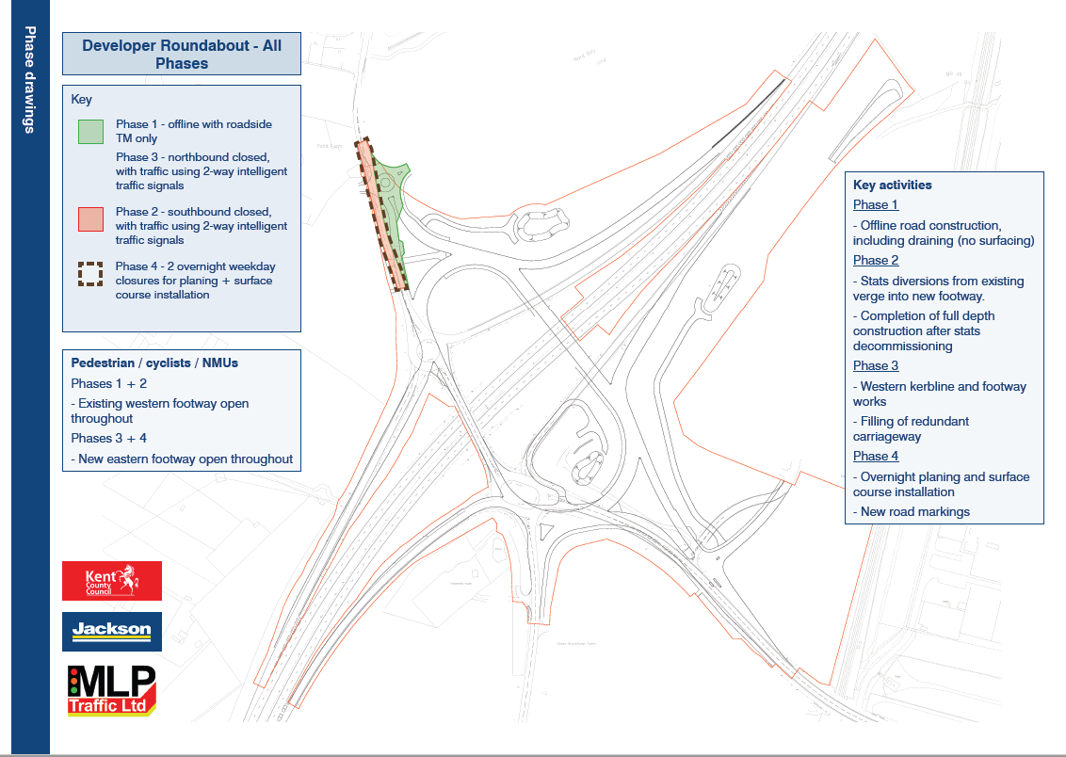
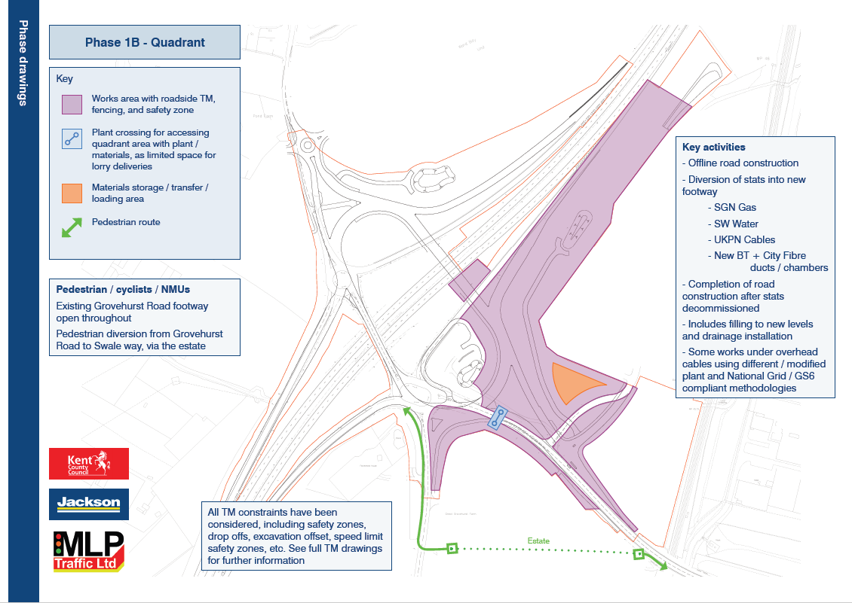
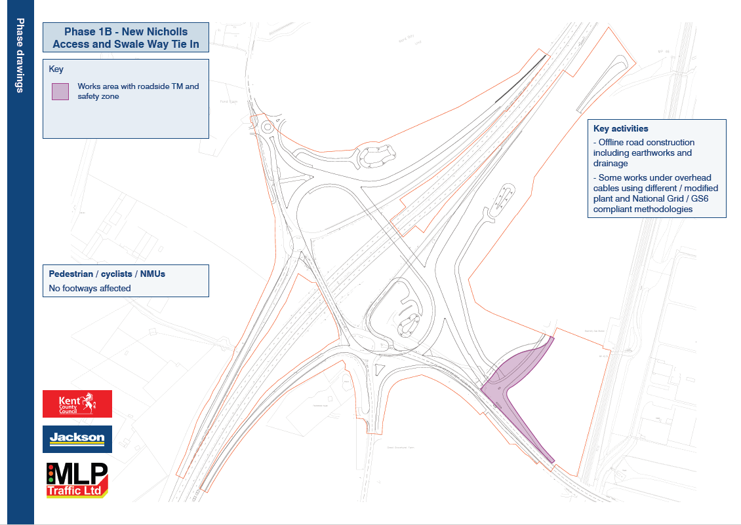
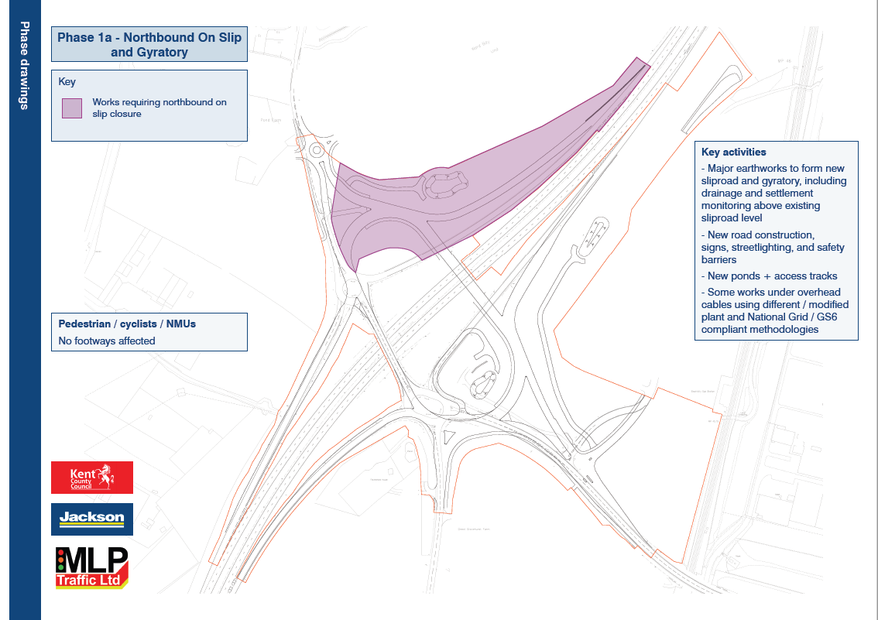
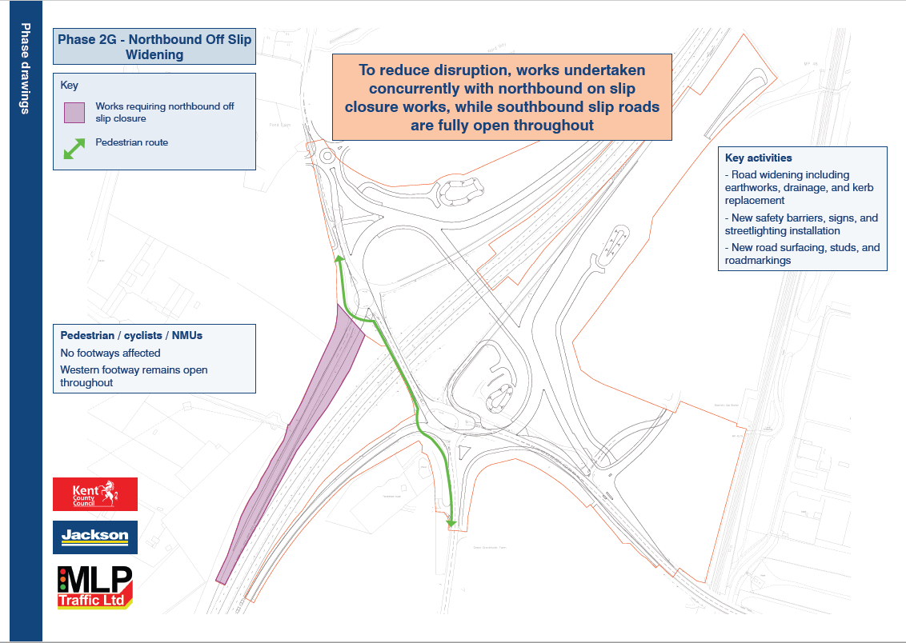
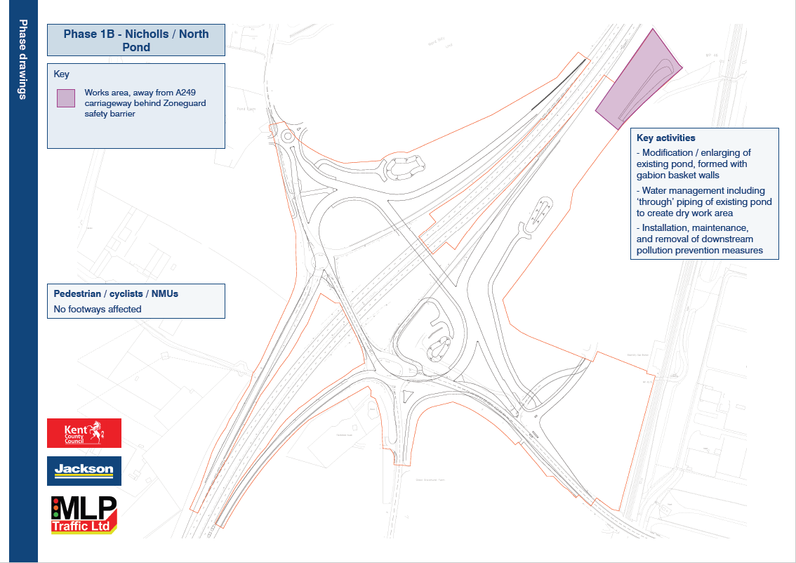
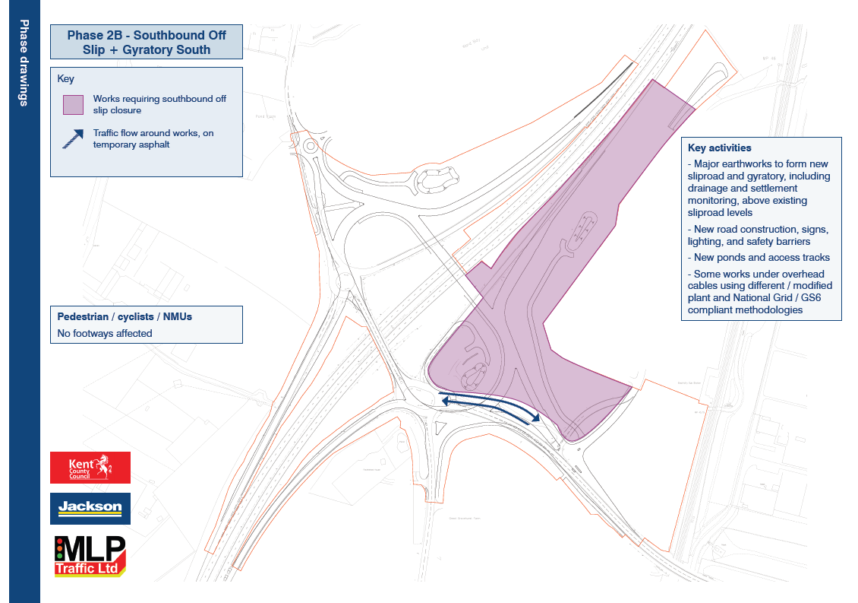
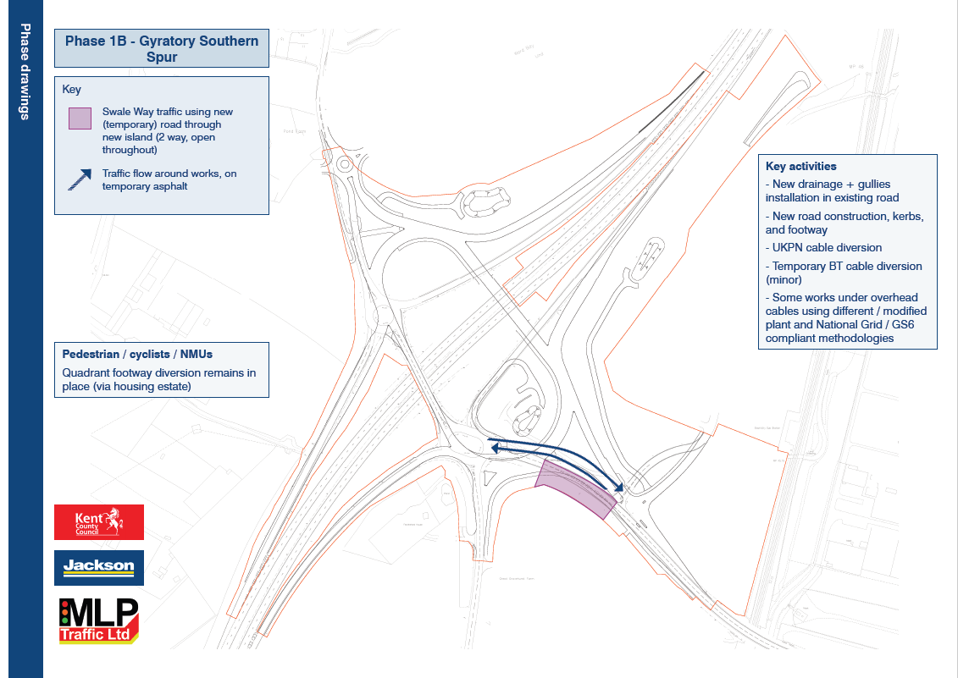
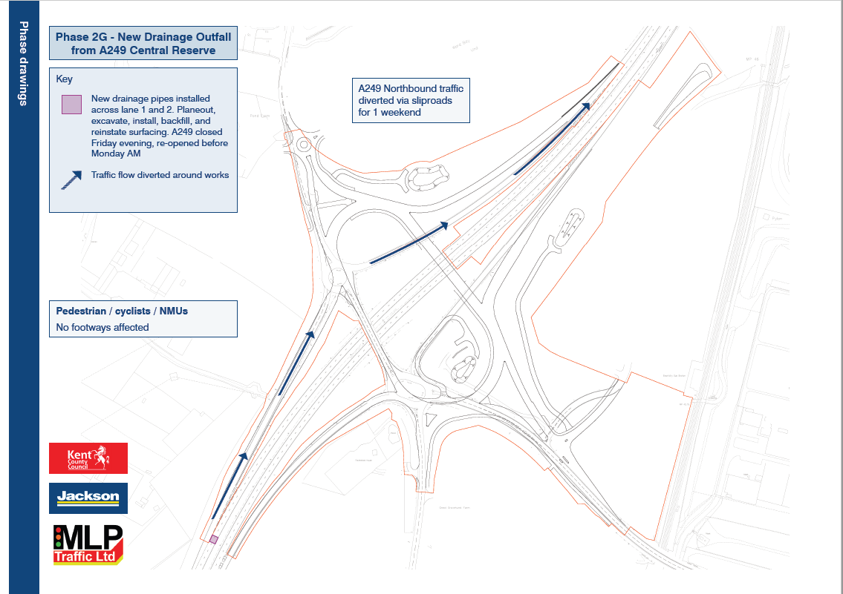
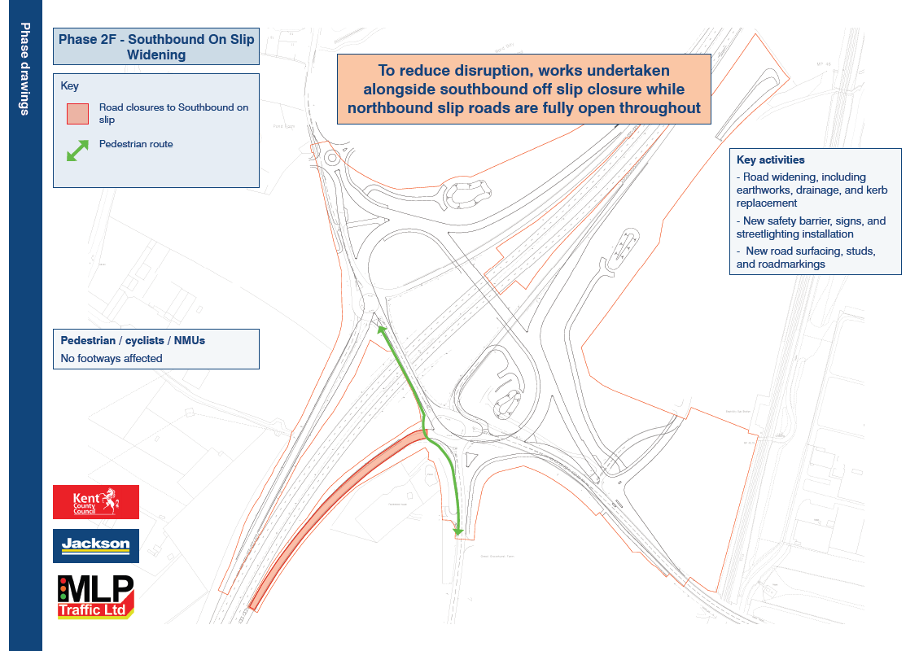
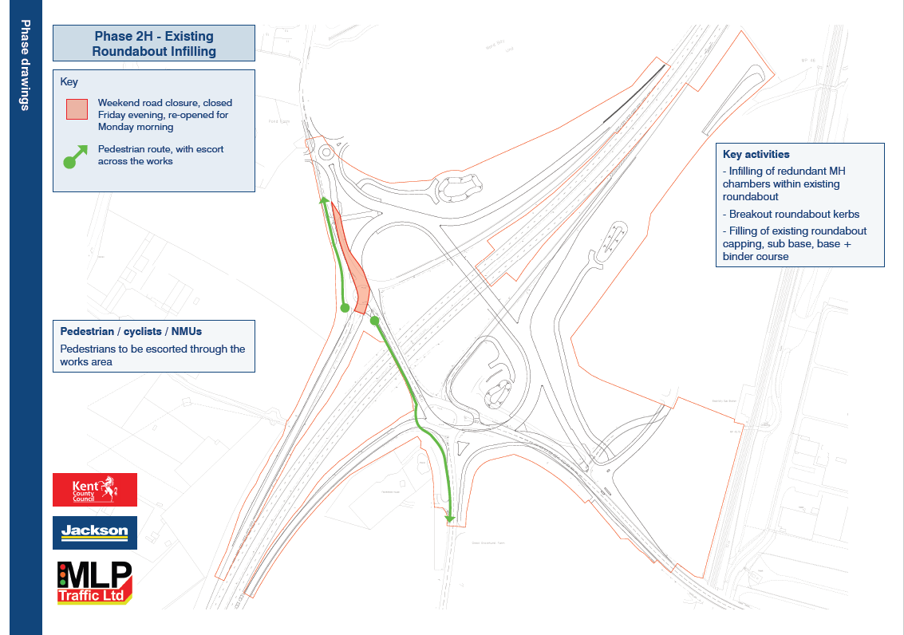
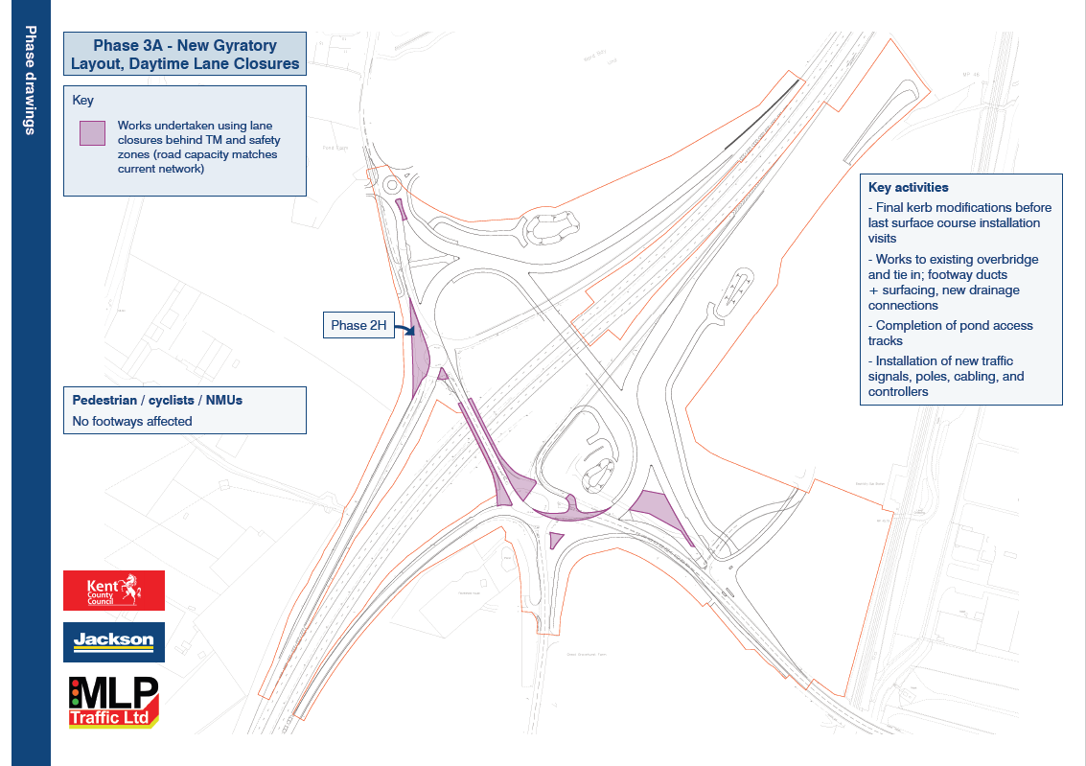
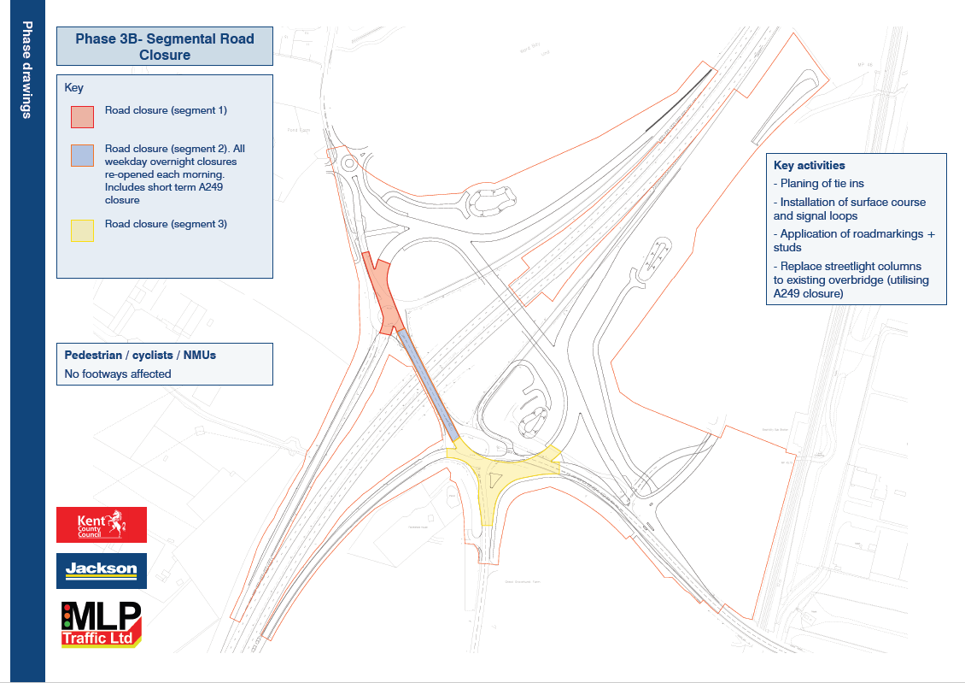

Appendix 3 – Core Documents

Compulsory Purchase Order

- Sealed copy of the Southern Gas Networks PLC (Kingsferry Gas Pipeline Replacement Project) Compulsory Purchase Order 2023 made 12 October 2023 including Schedule of Interests

- Order Map

- Statement of Reasons

- General Certificate

- Protected Assets Certificate

- Notice to Qualifying Persons

- Newspaper Notice

Legislation

- The Compulsory Purchase (Inquiries Procedure) Rules 2007

- Section 9 and Schedule 3, Gas Act 1986

- Section 6, Land Compensation Act 1961

- Schedule 3, Acquisition of Land Act 1981

- Section 6, Human Rights Act 1998

- Article 1 First Protocol, ECHR

- Section 10, Equalities Act 2010

- The Conservation of Habitats and Species Regulations 2017

- The Town and Country Planning (General Permitted Development) (England) Order 2015

- The Public Gas Transporter Pipe-line Works (Environmental Impact Assessment) Regulations 1999

- The Pipelines Safety Regulations 1996

Policy

- Energy White Paper, December 2020

- British Energy Security Strategy (April 2022)

- Powering Up Britain – The Energy Security Plan (March 2023)

- Powering Up Britain – The Net Zero Growth Plan (March 2023)

- Overarching National Policy Statement for energy (EN-1)

- National Policy Statement for Gas Supply Infrastructure and Gas and Oil Pipelines (EN-4)

- National Planning Policy Framework (December 2023)

- Bearing Fruits 2031: The Swale Borough Local Plan 2017

Guidance

- The CPO Guidance

- Guide 1 - Compulsory Purchase Procedure

- Guide 2 - Compensation to Business Owners and Occupiers

- Guide 3 - Compensation to Agricultural Owners and Occupiers

- Guide 4 - Compensation to Residential Owners and Occupiers

Other

- Screening Opinion of the Secretary of State (dated 9 May 2023)

30 SGN Gas Transporter Licence

31 Ofgem Final Determination dated 8 December 2020

32 Map showing footpaths ZR90, ZR88, ZS19 and ZS12

33 Map showing extend of public highway on Ridham Dock Road

34 Engineering Justification Paper (July 2019)

35 SGN Gas Network Innovation Strategy 2018

36 Summary of Route Options Report (January 2021) and Appendices (financial information redacted)

Objections

37 Objection 1: Southern Water in respect of Plot Nos. 1-4, 6, 7, 9-14, 16, 17, 20-27, 32, 34, 36-44, 47, 48, 53, 54, 57, 59, 62, 64-67, 69-80 and 83;

38 Objection 2: Network Rail Infrastructure Limited in respect of Plots Nos. 31-35, 37-44, 48, 49, 54, 55, 62, 64, 69 and 70;

39 Objection 3: Outback UK Propco I A Ltd in respect of Plot Nos. 34-36 and 46;

40 Objection 4: Knauf (UK) GmbH in respect of Plot Nos. 36 and 46;

41 Objection 5: Countryside Recycling Ltd in respect of Plot Nos. 36 and 46;

42 Objection 6: Grovehurst Energy Limited (subsidiary of D.S. Smith Group) in respect of Plot Nos. 36 and 46;

43 Objection 7: Manweb Nomineeco Limited in respect of Plot Nos. 36 and 46; and

44 Objection 8: Ridham Sea Terminals Limited in respect of Plot Nos. 36 and 46.

s3(2) of the Utilities Act 2000 substituted "the Authority" for the words "the Director", with the Authority meaning the Gas and Electricity Markets Authority operating through the Office for Gas and Electricity Markets (Ofgem)
Only 10 agreements are required because (i) one parcel of land is owned by two separate entities and terms have been agreed separately with each entity and (ii) one interest holder disposed of their parcel following agreement of terms but prior to exchange of option agreement
Please refer to https://sgn.co.uk/about-us/debt-investor-relations to access SGN’s latest credit rating agency reports.

